Html program for creation of website with forms,frames,links and tables.

Using Forms:

<html>
<body>
<form>
first name:<br>
<input type="text" name="first name">
<br>
last name:<br>
<input type="text"name="last name">
</form>
<input type="radio"name="sex" value="male">male <br>
<input type="radio"name="sex"value="female">female<br>
<input type="submit"value="click">
</form>
</body>
</html>

Output:

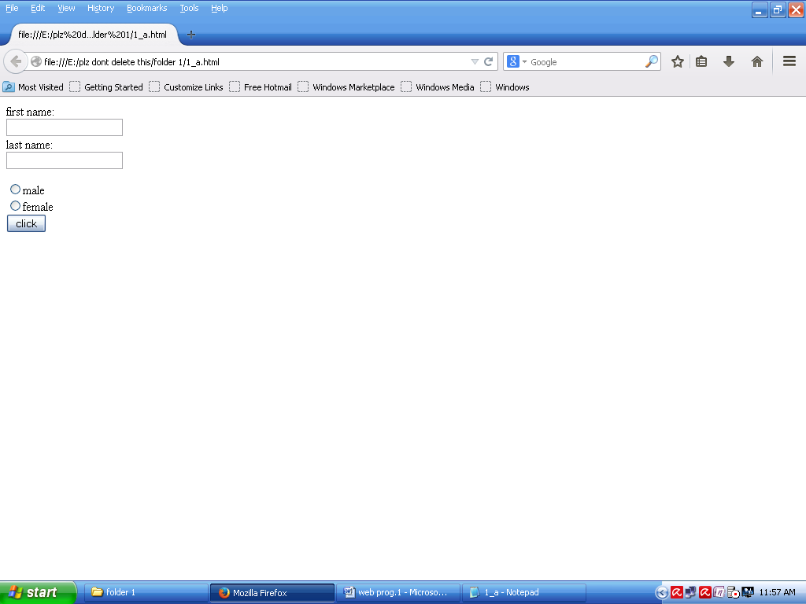

Using Frames:

<html>
<body>
<form action="action_page.php">
<fieldset>
<legend>personal information:</legend>
first name:<br>
<input type="text"name="first name" value="mickey">
<br>
last name:<br>
<input type="text"name="last name" value="mouse">
<br>
<br>
<input type="submit"value="submit">
</fieldset>
</body>
</html>

OUTPUT:
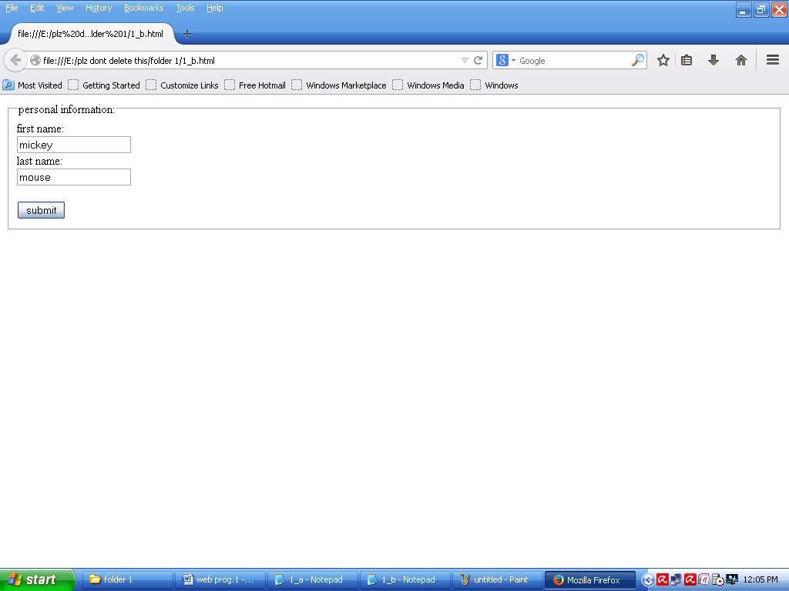

Using LINKs:

<html>
<head>
<style>
a:link{
color:green;
background-color:transparent;
text-decoration:none;
}
a:hover{
color:red;
background-color:transparent;
text-decoration:underline;
}
a:active{
color:yellow;
background-color:transparent;
text-decoration:underline;
}
</style>
</head>
<body>
<p>you can change the default colors of links</p>
<a href="html_images.asp"target="_blank">html images</a>
</body>
</html>

OUTPUT:

USING TABLES:

<html>
<head>
<table style="width:100%">
<tr>
<th>first name</th>
<th>last name</th>
<th>age</th>
</tr>
<tr>
<td>jill</td>
<td>smith</td>
<td>50</td>
</tr>
<tr>
<td>eve</td>
<td>jackson</td>
<td>92</td>
</tr>
</table>
</head>
</html>

OUTPUT:

