Formatting:

<html>
<head>
<h1>Hai</h1>
<h2>Welcome</h2>
<h3 style="color:blue">To</h3>
<h1 style="color:red">Information Technology</h1>
<h2 style="color:green">Students</h2>
<h1 style="font_family:verdana">Gud evening</h1>
<h3 style="font_family:monotype corsiva">Happy to see u all</h3>
<h4 style="font_family:Times new Roman">How r u?</h4>
<h2 style="font_size:200%">How Is Web Programming</h2>
</head>
</html>

Output:
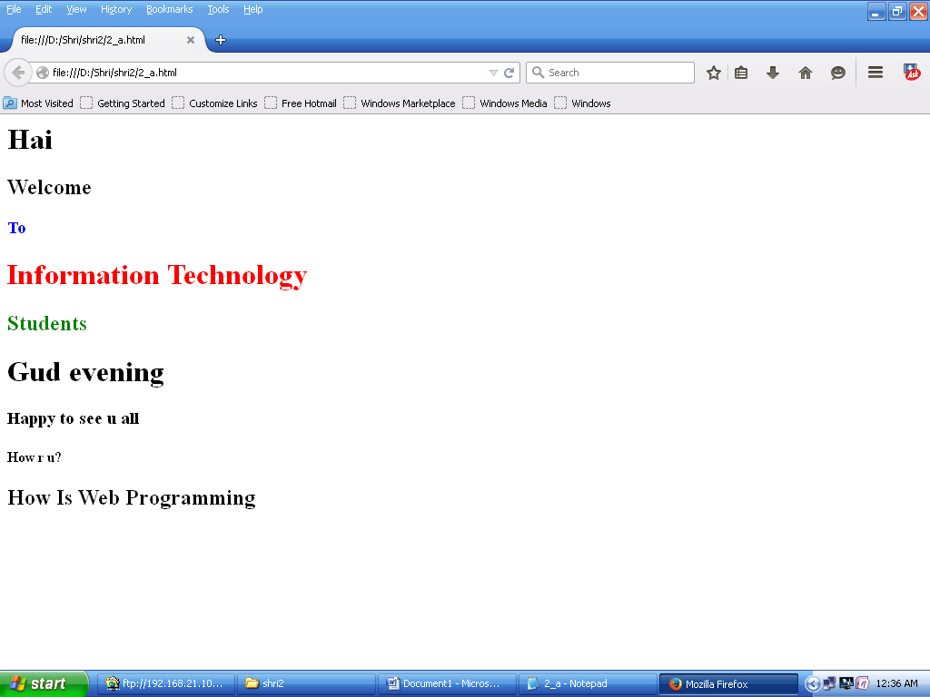

Using Images:
<html>
<head>
<img src="sunset.jpg"alt="sunset"width="800"height="550">
</head>
</html>

Output:
