Ex.No:1a
Date: CREATING ADVERTISEMENT
AIM:
To prepare an advertisement for a company with some specifications.
- Attractive page border.
- Use at least one Clip Art.
- Design name using Word Art.
- Use bullets.
ALGORITHM:
Step 1: Open a blank document.
Step 2: Go to Page LayoutPage BordersSelect Attractive Page BorderOk
Step 3: Go to InsertClip ArtSelect Attractive Clip ArtOk.
Step 4: Type a name and selectgo to insertWord ArtSelect a Word Art & click
Step 5: Type a brief company details & Right ClickSelect the Bullets Ok.
Step 6: Save the document.

OUTPUT:

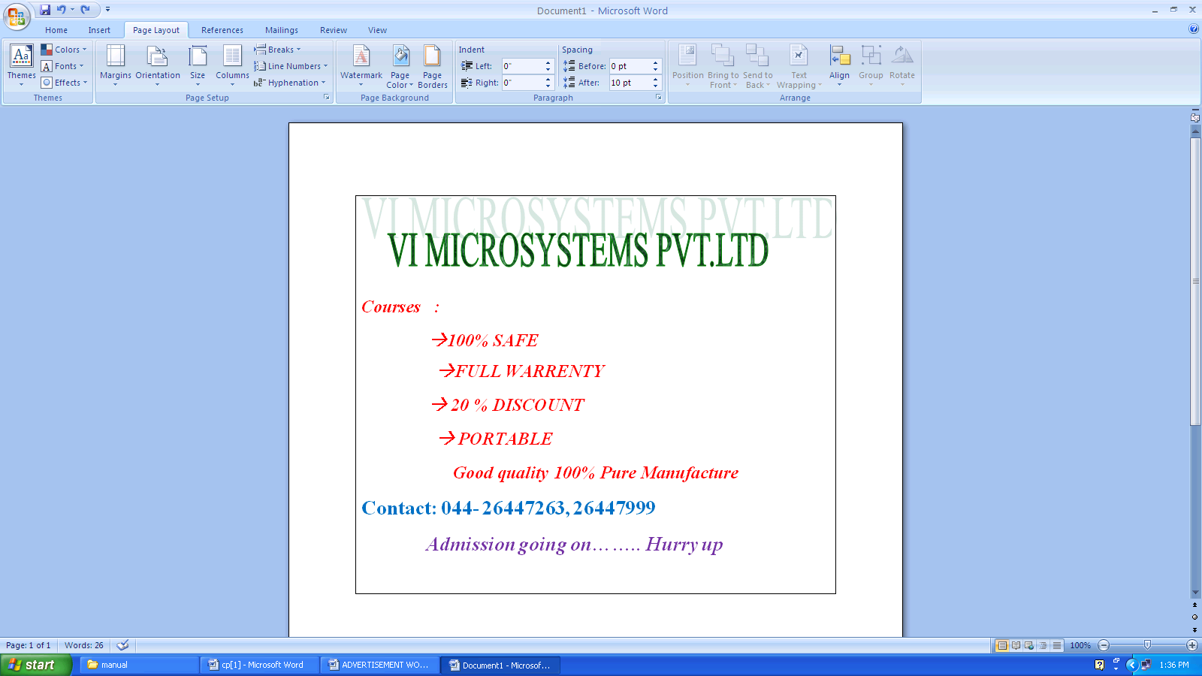

RESULT:-
Thus the advertisement has been created with some specifications in Microsoft word successfully and verified

Ex.No:1b
Date: CURRICULUM VITAE
AIM:
To create curriculum vitae (CV) of a B.E graduate with the specification.
- Table to show qualifications with heading.
- Left & Right margins
- Page numbers in the footer on the right side.
- Use Watermark.
ALGORITHM:
Step 1: Open a blank document.
Step 2: Type a Bio-data briefly then goto Insert TableInsertTableSelect
no of rows & columnsOk for qualifications.
Step 3: Go to Page LayoutMarginsAssignLeft & Right Margins
Step 4: Go to Insert Page NumbersSelect footer on the right sideOk.
Step 5: Go to Page LayoutWatermarkCustomize text as Bio-dataOk.
Step 6: Save the Document.

OUTPUT:

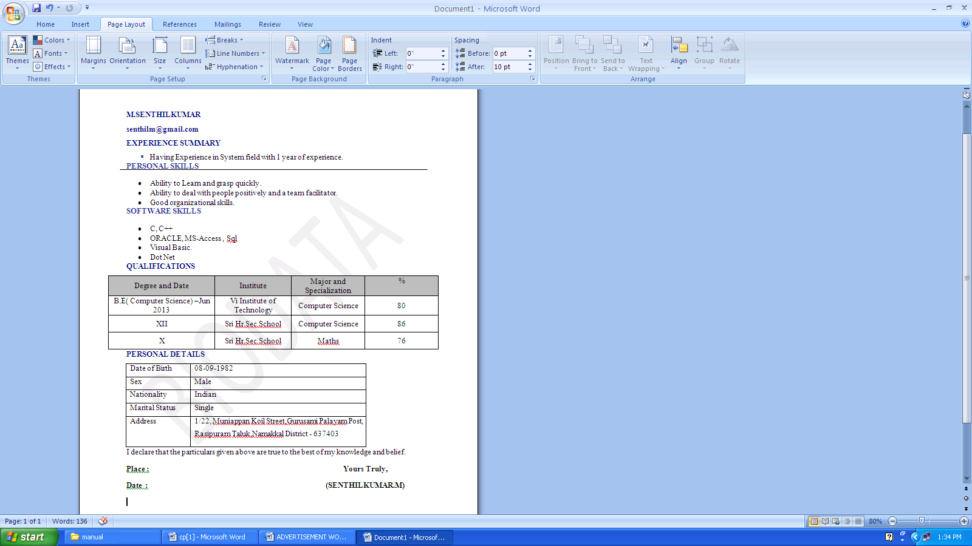

RESULT:-
Thus the curriculum vitae (CV) has been created with some specifications in Microsoft word successfully and verified.

Ex.No:1c
Date: SCIENTIFIC NOTATIONS

AIM:
To create a MS-WORD document for the following scientific notation
- A=$a_{0}^{2}$+${ a}_{1}^{3}$+ $b_{0}^{2}$ + $b_{1}^{-4}$
- $x_{1 }y_{1}$ +$x\frac{{(y+z)}^{2}}{x^{2}+y^{2}}$
- $x=\frac{-b±\sqrt{b^{2}-4ac}}{2a}$
- $T\left(x\right)=\sum_{i=1}^{m}{\sum_{j=1}^{n}{c_{ij}} t_{ij}} x_{ij}$
- $2c_{2}H_{6}\left(9\right)$ + 7$o_{2}\left(g\right)$4${co}_{2 }\left(g\right)$ + 6$H_{2}$o
ALGORITHM:
Step 1: Open a blank document.
Step 2: Go to InsertEquationInsert EquationSelect the specific format.
For eg , $e^{x}$ for $a^{2}$,$a^{-4}$…………..
Step 3: Select for $\sum_{i=1}^{m}{\sum_{j=1}^{n}{}}$
Step 4: Select for $\frac{{x(y+z)}^{2}}{x^{2}+y^{2}}$
Step 5: Save the document.

OUTPUT:

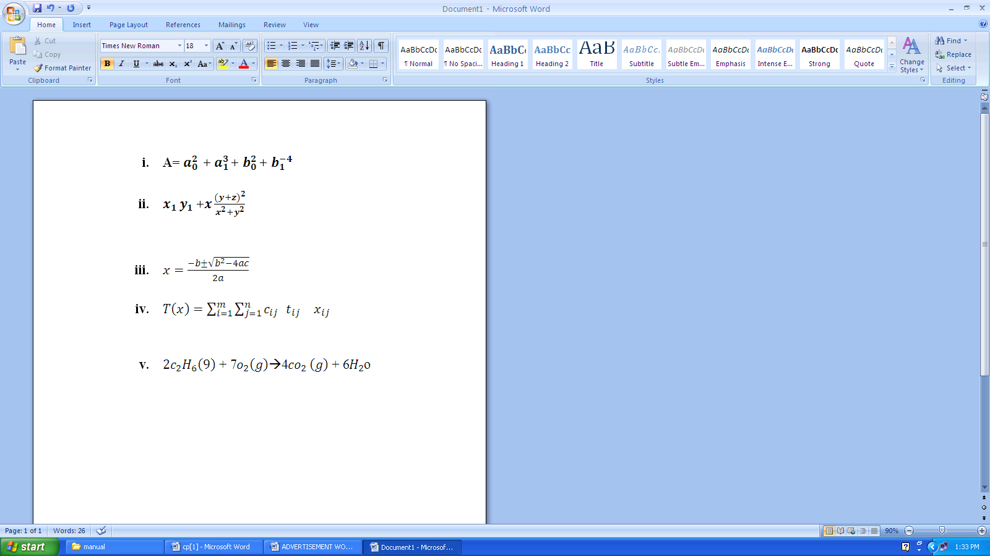

RESULT:-
Thus the scientific notations has been created in Microsoft word successfully and verified.

Ex.No:2
Date: CREATING TIME TABLE & CONVERSION

AIM:
To prepare a class timetable using Merge rows, Split row, Insert rows - columns etc and convert the table into text format.
ALGORITHM:
Step1: Open a blank document.
Step 2: InsertTableInsert TableSelect No of rows & columnsOk.
Step 3: Select two cells Right click Merge Cells.
Select one cell Right clickSplit Cell
Select one row Right click InsertInsert One row above or below
Select one column Right click InsertInsert One column left or right
Step 4: Type a Class Timetable with Headings
Step 5: Go to LayoutConvert to textSelect Tabs Ok
Step 6: Save the document as Table and Text Format

OUTPUT:

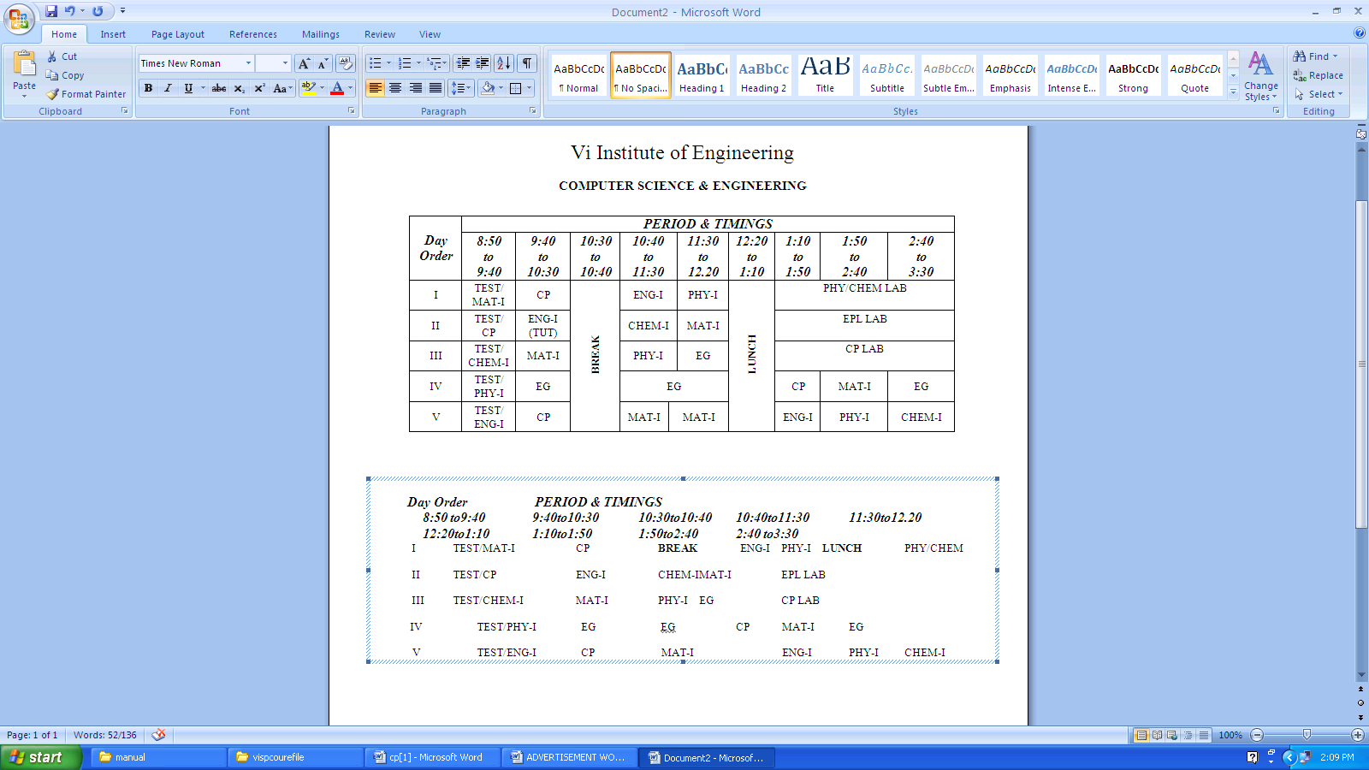

RESULT:-
Thus the class time table has been created & table is converted into text in Microsoft word successfully and verified.

Ex.No:3a
Date: MAIL MERGE & LETTER PREPARATION

AIM:-
To create a WORD document to call letters for an interview using Mail Merge send to10 candidates

ALGORITHM:-
- Open a blank document
- Goto Mailings in Menu Start Mail merge Letters
- Type a interview call letter with FROM address and leave some
Space for TO address
- Goto Select recipients Type a new list Customize the
Columns Ok
- Type a 10 address new some fieldsOksave it
- Goto Select recipients Use Existing list open a file Ok
- Under the TO Address insert the Merge fields & preview the results
- Goto Finish MergeEdit individual Documents All Ok
- Save the document

OUTPUT:

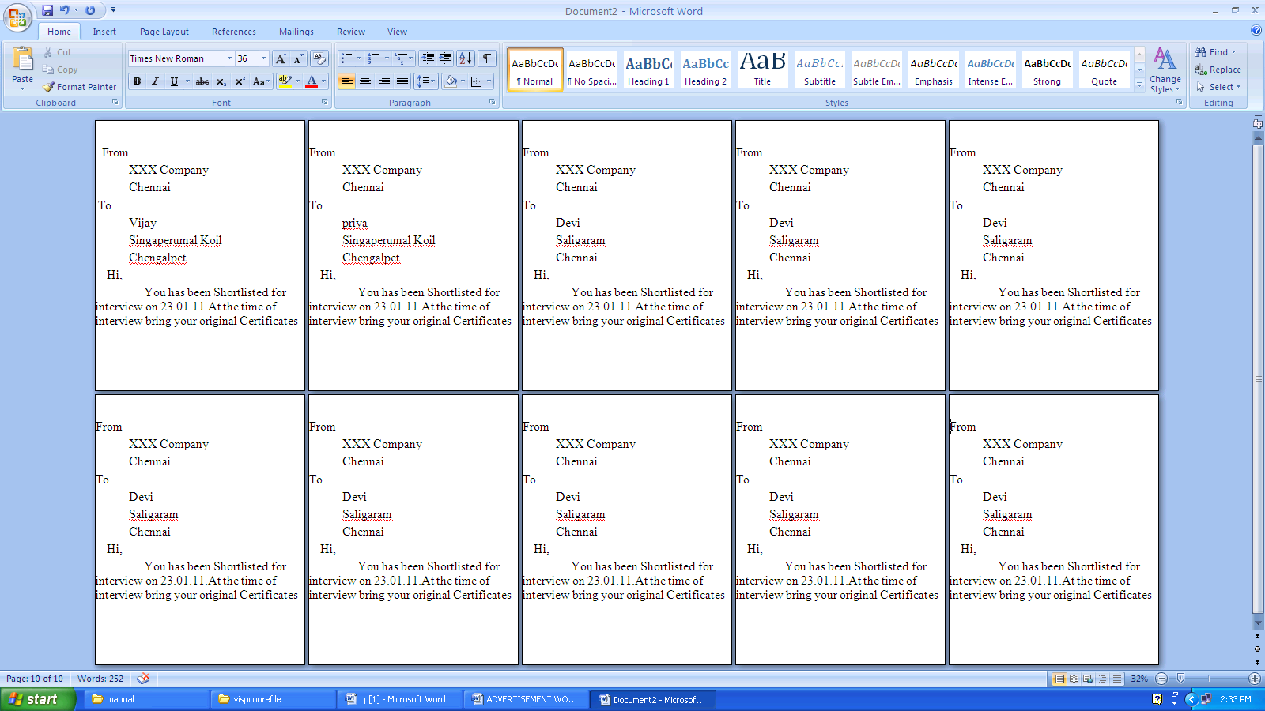

RESULT:-
Thus the Mail Merge has been created in Microsoft word successfully and Verified.

Ex.No:3b
Date: VISITING CARD

AIM:-
To design a visiting card for a Managing Director of a company with the Size of 3.25 inch * 2.5 inch

ALGORITHM:-
- Open a blank document
- Goto Page layout Size More Paper Size Assign width 3.25
& height is 2.5 Ok
- Type a visiting card with address and some images
- Save the document

OUTPUT:

RESULT:-
Thus the visiting card for a Managing Director of a company has been created in Microsoft word successfully and verified.

Ex.No:4
Date: DRAWING FLOW CHART

AIM:-
To create a flowchart in WORD to find the greatest of three numbers
ALGORITHM:-
- Open a blank document
- Goto Insert shapesFlowchart
- Insert the Correct shapes for Input box decision box ,Calculation
box and Output box
STEP 4: Select the box and Right Click Add Text
STEP 5: Use Arrows for Link
STEP 6: Save the document

OUTPUT:

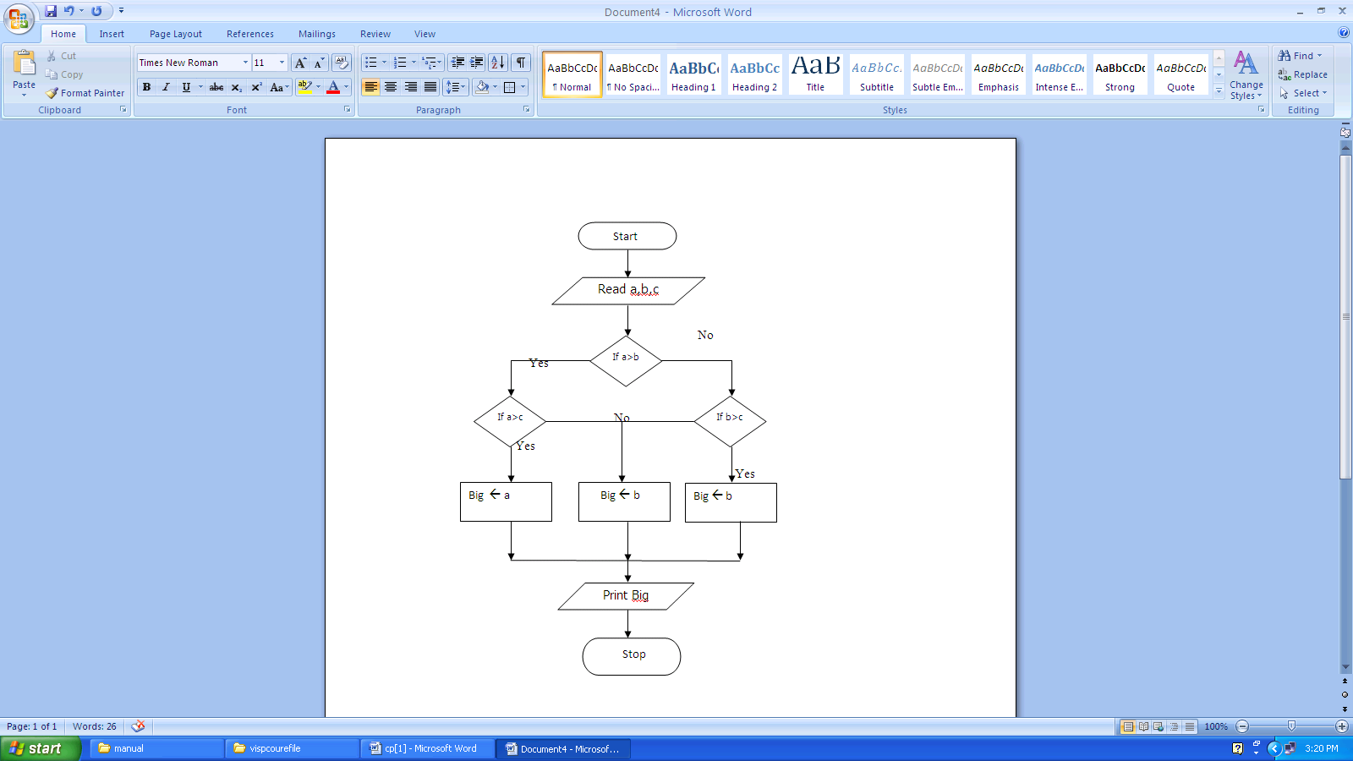

RESULT:-
Thus the flowchart in WORD to find the greatest of three numbers has been created in Microsoft word successfully and verified.

Ex.No:5
Date:
SPREAD SHEET CHART (Line,XY,Bar and Pie)

AIM:-
To create a EXCEL to analyze the marks of the students of a class using various
Chart (Line,XY,Bar and Pie).
ALGORITHM:-
- Open a Microsoft Excel Worksheet.
- Place the Cursor on the desired cell and start entering the required
Student details
- To find the Total and Average using formula (Total = m1+m2+m3)
Average = (Total / 3)
- Select the table and goto Insert Chart Choose one type of
Chart
STEP 5: Reselect the table again and Insert Chart Choose another
type of Chart like wise do for all charts
STEP 6: Save the Excel Sheet

OUTPUT:

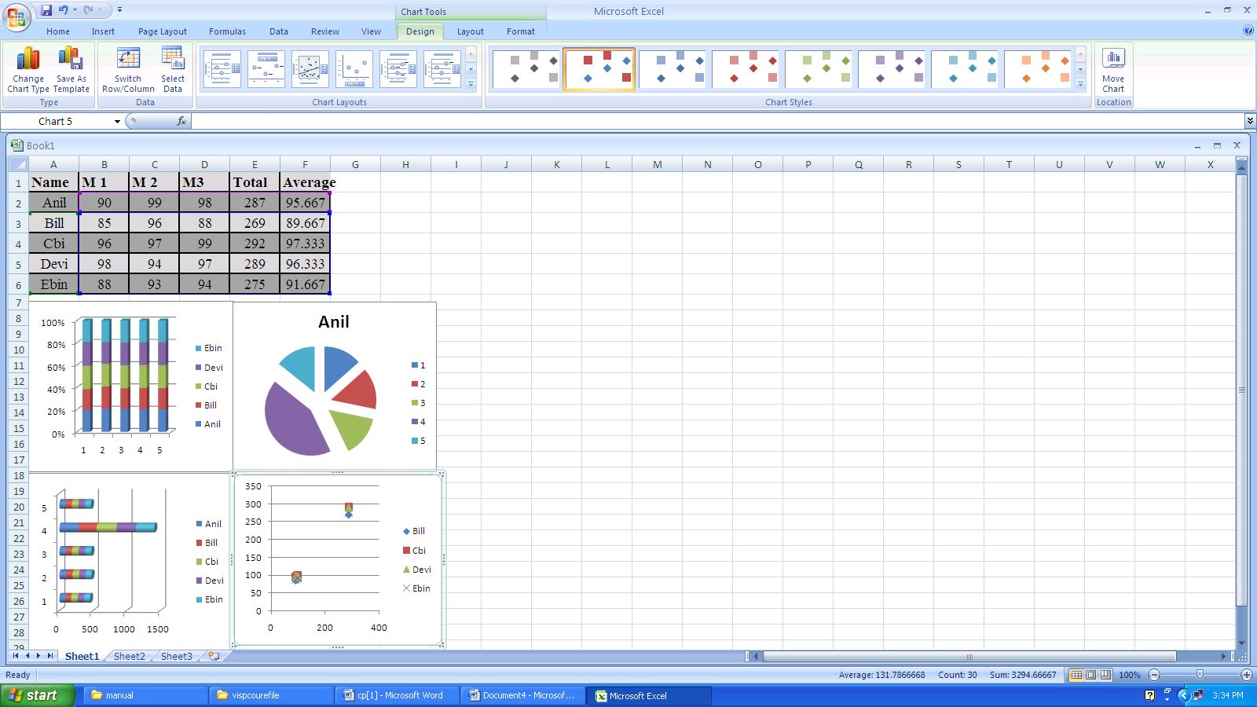

RESULT:-
Thus the Spreadsheet charts (Line,XY,Bar and Pie)for students marks has been created Successfully and verified.

Ex.No:6
Date: SPREAD SHEET FORMULA EDITIR
AIM:-
To create a spreadsheet to calculate HRA ,DA,TA,PF,LIC.Gross Salary ,Net Salary from the given data
HRA=18% of basic Pay TA=12% of Basic Pay DA=15% of Basic Pay
PF =10% of Basic Pay LIC =7% of Basic Pay Deduction= PF + LIC
Gross Salary = Basic Pay + HRA + DA + TA Net Salary = Gross Salary – Deduction
ALGORITHM:-
STEP 1: Open a Microsoft Excel Worksheet
STEP 2: Type the details about the employees and Basic Salary.
STEP 3: For HRA & DA, move to corresponding row & column and assign the
Formula =18/100* BS (row & column) For DA ,move to corresponding
row & column and assign theormula =15/100* BS (row & column)
STEP 4: For TA & PF, move to corresponding row & column and assign the
formula =12/100* BS (row & column) For PF ,move to corresponding
row & column and assign the formula =10/100* BS (row & column)
STEP 5: For LIC & GS, move to corresponding row & column and assign the
formula=7/100* BS,For GS ,move to corresponding row & column and
assign the formula = Basic Pay + HRA + DA + TA
STEP 6: Likewise for Deduction and Net Salary and Save the ExcelSheet

OUTPUT:

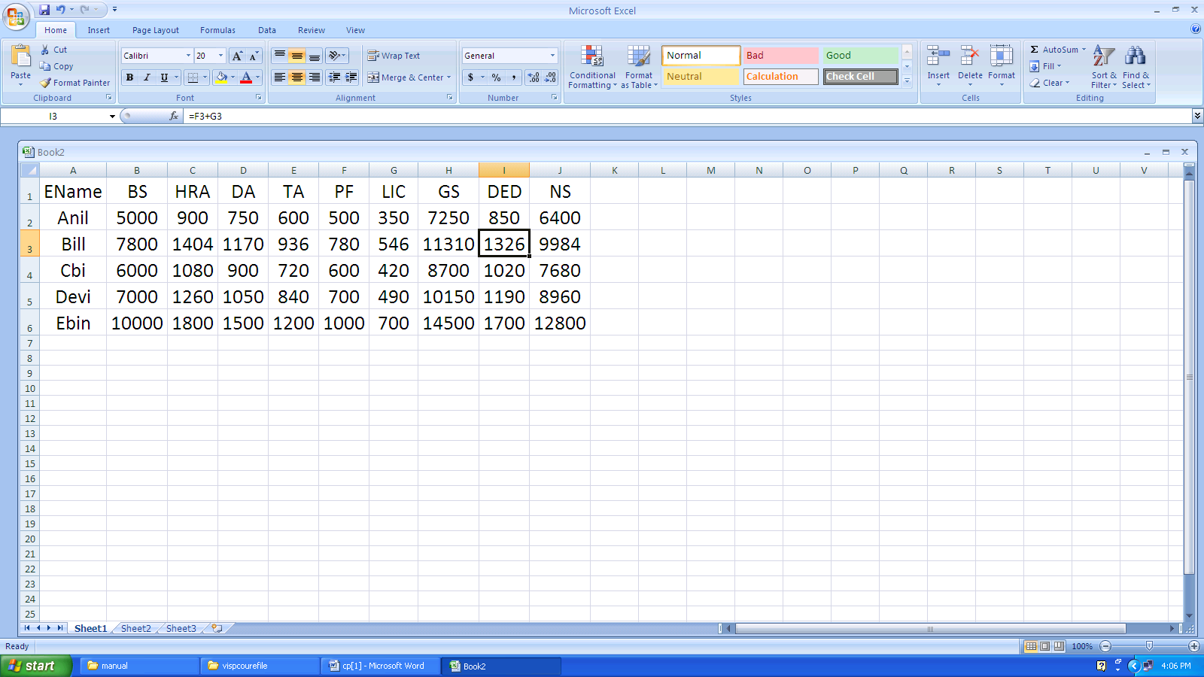

RESULT:-
Thus the Spreadsheet to calculate HRA ,DA,TA,PF,LIC.Gross Salary ,Net Salary from the given data has been created Successfully and verified.

Ex.No:7
Date: PROTECT SPREAD SHEET
AIM:-
To create a spreadsheet insert a Picture and apply the option of protecting the
document
ALGORITHM:-
STEP 1: Open a Microsoft Excel Worksheet
STEP 2: Goto Insert Select the Picture Insert and type some Text.
STEP 3: Goto Review Protect Sheet Set a Password & Reenter the Password
STEP 4: For Unprotect again Goto Review UnProtect Sheet Type Password
STEP 5: Modify the Worksheet and protect it
STEP 6: Save the ExcelSheet

OUTPUT:

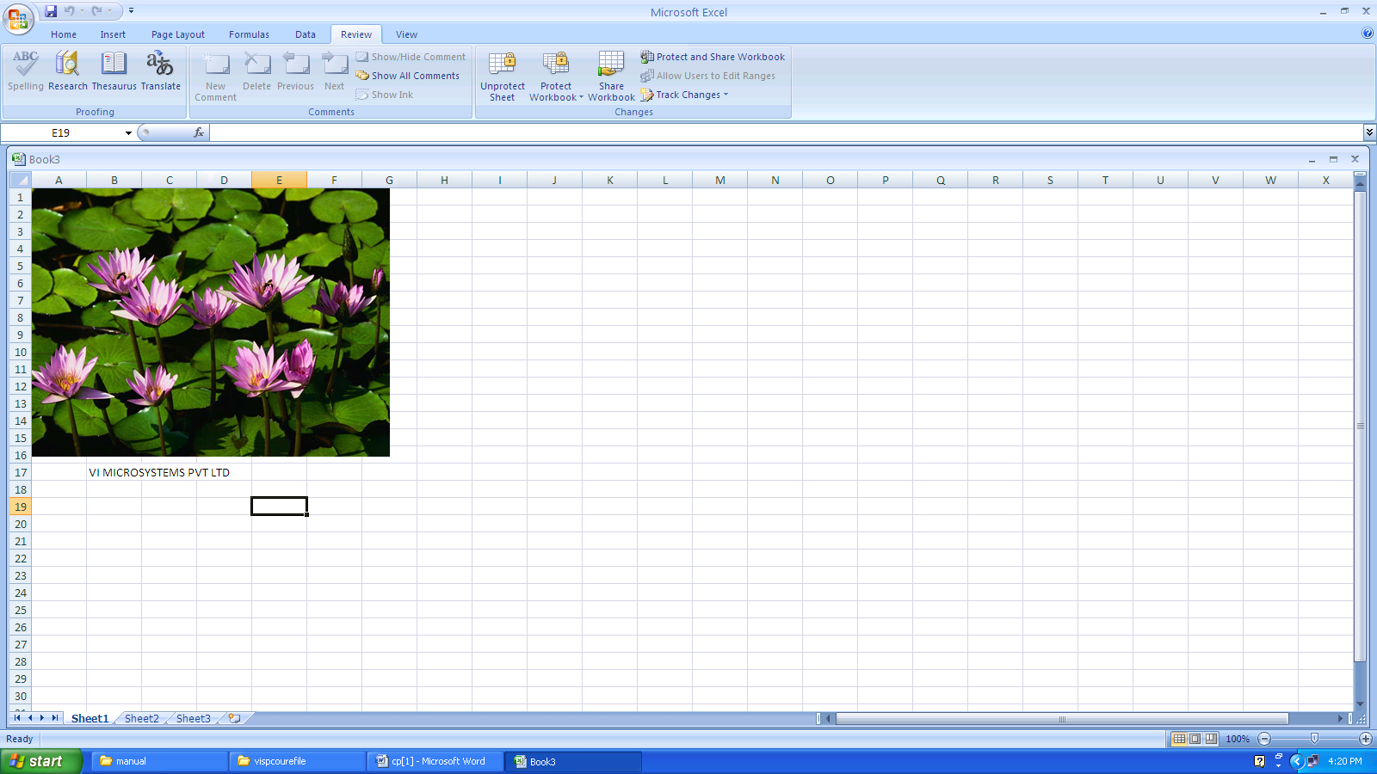

RESULT:-
Thus the inclusion of object in worksheet and protected successfully and
Verified.

Ex.No:8
Date:
SPREAD SHEET SORTING & IMPORT /EXPORT FEATURES
AIM:-
To create a spreadsheet to sort the names and sort the numbers and convert the numbers
Decimal numbers:- 243,46,173,425,625
Binary numbers:-11011, 1110110101, 11001, 11111
ALGORITHM:-

- Open a Microsoft Excel Worksheet.
- Type some list of names in randomly
- Select the names and Right click SortSelect the names and sort
In Ascending Order ( A to Z)
- Select the numbers and Right click SortSelect the numbers and
sort In Ascending Order ( Small to Large)
- For Conversion Goto Formula Select More
FunctionsEngineeringSelect DEC2BIN, DEC2HEX,DEC2OCT
and BIN2DEC,BIN2HEX,BIN2OCT etc
STEP 6: Save the ExcelSheet

OUTPUT:

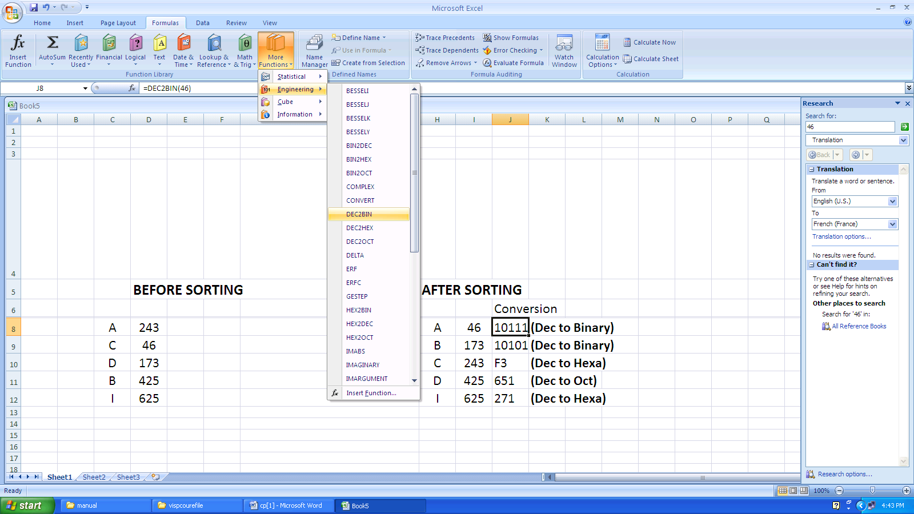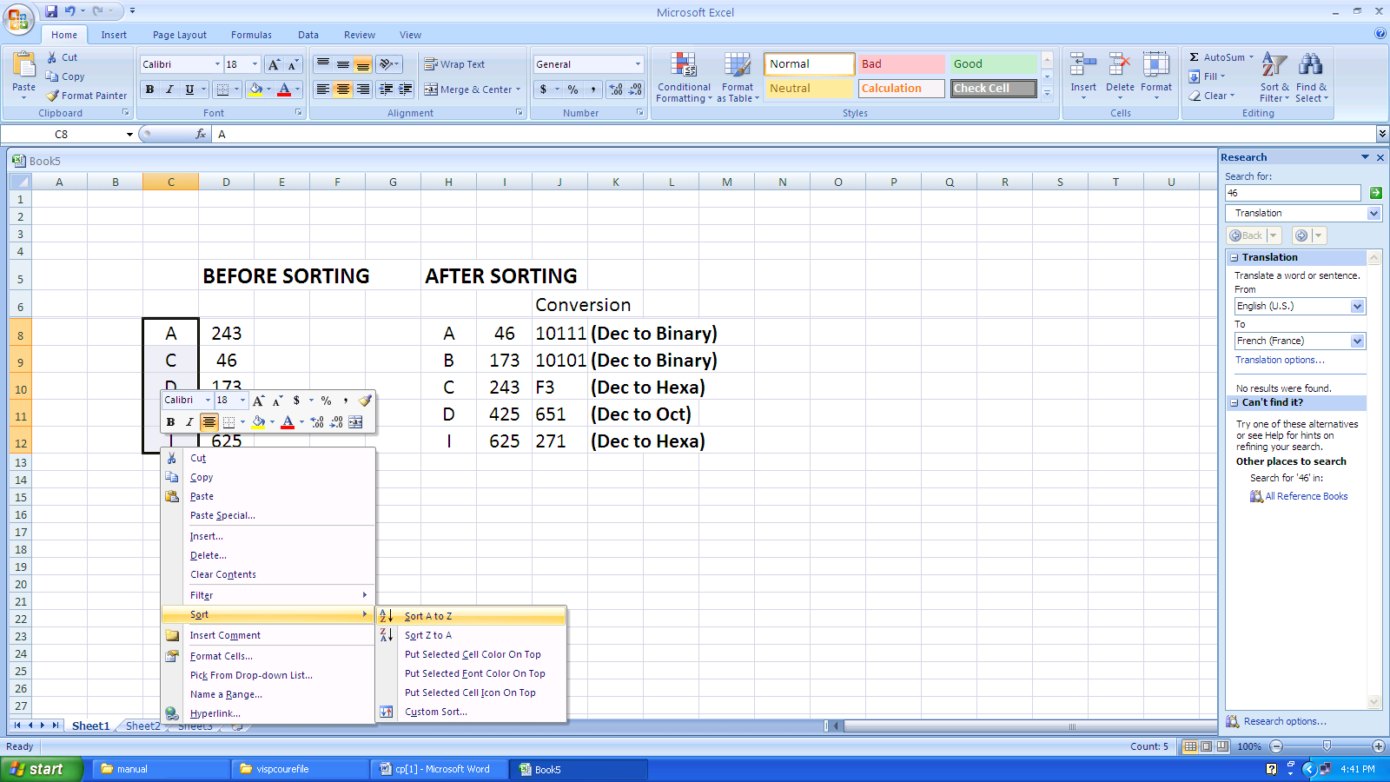

RESULT:-
Thus the worksheet name & Numbers are sorted and Conversion (Import/Export Features)has been created successfully and Verified.

PROGRAM:

#include<stdio.h>
main()
{
float b;
int a;
printf("\nEnter an Integer\n");
scanf("%d",&a);
b=(float)a;
printf("\nThe Converted float value is %f",b);
}

OUTPUT:
Enter an Integer
45
The Converted float value is 45.00000

PROGRAM:

#include<stdio.h>
main()
{
int a,b,c;
printf("Enter Number 1\n"); scanf("%d",&a); printf("Enter Number 2\n");
scanf("%d",&b);
c=a*b;
printf("\nThe Multiplication Result is %d\n",c);
}

OUTPUT:
Enter Number 1
34
Enter Number 2
7
The Multiplication Result is 238

PROGRAM:
#include<stdio.h>
main()
{
int m1,m2,m3,m4,m5,tot;
float avg;
printf("Enter 5 Marks\n"); scanf("%d%d%d%d%d",&m1,&m2,&m3,&m4,&m5); tot=m1+m2+m3+m4+m5;
avg=tot/5;
printf("\n The Average is %f\n",avg);
}

OUTPUT:
Enter 5 Marks
88
84
79
90
94
The Average is 87

PROGRAM:
#include<stdio.h>
main()
{
int v,g,c,d,dr;
float r,nr;
printf("Enter the value of v\n");
scanf("%d",&v);
printf("Enter the value of g\n");
scanf("%d",&g);
printf("Enter the value of c\n");
scanf("%d",&c);
printf("Enter the value of d\n"); scanf("%d",&d); nr=(2*v)+(6.22*c*d);
dr=g+v;
r=nr/dr;
printf("The Evaluated Result is %f\n",r);
}

OUTPUT:
Enter the value of v
2
Enter the value of g
4
Enter the value of c
6
Enter the value of d

8
The Evaluated Result is 50.426666

PROGRAM:

#include<stdio.h>
main()

{
int mm,m;
printf("Enter the Millimeter\n");
scanf("%d",&mm);
m=mm*1000;
printf("The Converted meter is %d",m);
}

OUTPUT:
Enter the Millimeter
12
The Converted meter is 12000

PROGRAM:
#include<stdio.h>
main()
{
int a,rem;
printf("Enter a Number\n");
scanf("%d",&a); rem=a%2; if(rem==0)
printf("The Given Number is Even");
else
printf("The Given Number is Odd");
}

OUTPUT:
Enter a Number
13
The Given Number is Odd

PROGRAM:
#include<stdio.h>
main()
{
int a,b,c;
printf("Enter 3 Numbers\n"); scanf("%d%d%d",&a,&b,&c); if(a>b)
{
if(a>c)
{
printf("The First Number %d(a) is Biggest\n",a);
}
}
else if(b>c)
16
{
printf("The Second Number %d(b) is Biggest\n",b);
}
else
printf("The Third Number %d(c) is Biggest\n",c);
}

OUTPUT:
Enter 3 Numbers
5
9
2
The Second Number 89(b) is Biggest

PROGRAM:
#include<stdio.h>
main()
{
int i,n,sum=0;
printf("Enter the range\n");
scanf("%d",&n);
i=1;
while(i<=n)
{ sum=sum+i; i++;
}
printf("\nThe sum of first %d numbers is %d\n",n,sum);
}

OUTPUT: Enter the range
16
The sum of first 16 numbers is 136

PROGRAM:
#include<stdio.h>
main()
{
int n,i,sum=0;
printf("Enter a Number\n");
scanf("%d",&n);
do
{ i=n%10; sum=sum+i; n=n/10;
}while(n>0);
printf("The Sum of digit is %d\n",sum);
}

OUTPUT:
Enter a Number
5891
The Sum of digit is 23

PROGRAM:
#include<stdio.h>
#include<conio.h>
#include<math.h>
void main()
{
int no,i;
float x,a,sum,b;
clrscr();
printf("enter the number");
scanf("%f%d",&x,&no);
b=x;
x=x*3.14/180;
a=x;
sum=x;
for(i=1;i<no+1;i++)
{
a=(a*pow((double)(-1),(double)(2*i-1))*x*x)/(2*i*(2*i+1));
sum=sum+a;
}
printf("sine(%f)value is%f",b,sum);
getch();
}

OUTPUT:

enter the number 90
sine value is 1.00

PROGRAM:
#include<stdio.h>
#include<conio.h>
#include<math.h>
main()
{
float x,a,sum,temp;
int i,no=20,mul;
clrscr();
printf("\n Enter the value of x");
scanf("%f",&x);
a=x;
x=x*(3.14/180);
temp=1,sum=1;
for(i=1;i<no+1;i++)
{
temp=(temp*pow((double)(-1),(double)(2*i-1))*x*x)/(2*i*(2*i-1));
sum=sum+temp;
}
printf("\n the cosine value of %fis%f",a,sum);
getch();
return 0;
}

OUTPUT:

enter the number 90
cosine value is 0.0

PROGRAM:

#include<stdio.h>
main()
{
int a,b,ch,c;
printf("\nEnter the Number 1:\n");
scanf("%d",&a);
printf("\nEnter the Number 2:\n"); scanf("%d",&b); printf("\n1.Add\n2.Subtract\n3.Multiply\n4.Divide\n"); printf("\nEnter the Choice:\n");
scanf("%d",&ch);
switch(ch)
{
case 1:
c=a+b;
printf("\n %d + %d = %d\n",a,b,c);
break;
case 2:
c=a-b;
printf("\n %d - %d = %d\n",a,b,c);
break;
case 3:
c=a*b;
printf("\n %d * %d = %d\n",a,b,c);
break;
case 4:
c=a/b;
printf("\n %d / %d = %d\n",a,b,c);
break;
}
}

OUTPUT:

Enter the Number 1:
15
Enter the Number 2:

56

1.Add
2.Subtract
3.Multiply
4.Divide
Enter the Choice: 2
15 - 56 = -41

PROGRAM:

#include<stdio.h>
#include<math.h>
main()
{
int a,i,sum=0,n,ch,m; printf("\nEnter a Number\n"); scanf("%d",&a);

printf("\n1.Palindrome\n2.Armstrong\n3.Prime\n");
printf("\nEnter the Choice:\n");
scanf("%d",&ch);
switch(ch)
{
case 1: n=a; while(a>0)
{ i=a%10; sum=(sum*10)+i; a=a/10;
}
if(n==sum)
printf("Given Number is Palindrome\n");
else
printf("Given Number is Not Palindrome\n");
break; case 2: n=a;
do
{ i=a%10; sum=sum+(i*i*i);
a=a/10;
}while(a>0);
if(n==sum)
printf("Given Number is Armstrong\n");
else
printf("Given Number is Not Armstrong\n");
break; case 3: m=5; n=sqrt(a);

for(i=2;i<=n;i++)
{
if(a%i==0)
{ m=0; break;

}
}
if(m==0)
printf("Given Number is Prime\n");
else
printf("Given Number is Not Prime\n");
break;
}
}

OUTPUT:
Enter a Number
121
1.Palindrome
2.Armstrong
3.Prime
Enter the Choice:
1

Given Number is Palindrome

PROGRAM:

#include<stdio.h>
#include<conio.h>
void main()
{
int fact=1,i,num;
clrscr();
printf("Enter the number");
scanf("%d",&num);
for(i=1;i<=num;i++)
{
fact=fact*i;
}
printf("The factorial of %d is %d",num,fact);
getch();
}

OUTPUT:

Enter the number
5
The factorial of 5 is 120

PROGRAM:

#include<stdio.h>
#include<conio.h>
void main()
{
int num,fib=0,a=0,b=1,i;
clrscr();
printf("Enter the number");
scanf("%d",&num);
printf("FIBONACI,SERIES ");
if(num==0)
printf("0");
else
{
for(i=0;i<num;i++)
{
fib=fib+a;
a=b;
b=fib;
printf("%d",fib);
getch();
}
}
}

OUTPUT:
Enter the number 5
FIBONACCI SERIES 01123

PROGRAM:

#include<stdio.h>
#include<conio.h>
void main()
{
int bnum,digit,decimal=0,bin,base=0;
clrscr();
printf("\n enter the Binary no:");
scanf("%d",&bnum);
bin=bnum;
while(bnum!=0)
{
digit=bnum%10;
decimal=decimal+(digit<<base);
base=base+1;
bnum=bnum/10;
}
printf("\n the binary %d to decimal is=%d",bin,decimal);
getch();
}

OUTPUT:

PROGRAM:
#include<stdio.h>
main()
{
int i,n,a[10],sum=0;
printf("Enter total no. of Elements\n");
scanf("%d",&n);
printf("Enter Array elements one by one\n");
for(i=0;i<n;i++) scanf("%d",&a[i]); for(i=0;i<n;i++) sum=sum+a[i];
printf("The Sum of Array Elements is %d\n",sum);
}

OUTPUT:
Enter total no. of Elements
8
Enter Array elements one by one
15
69
32
10

45
66
32
11
The Sum of Array Elements is 280

PROGRAM:

#include<stdio.h>
main()
{
int i,n,a[10];
printf("Enter total no. of Elements\n");
scanf("%d",&n);
printf("Enter Array elements one by one\n");
for(i=0;i<n;i++)
scanf("%d",&a[i]);
printf("The even numbers of given array:\n");
for(i=0;i<n;i++)
{
if(a[i]%2==0)
printf("%d\n",a[i]);
}
}

OUTPUT:
Enter total no. of Elements
6
Enter Array elements one by one
98
11
35
61

22
14
The even numbers of given array:
98
22
14

PROGRAM:
#include<stdio.h>
int main(){
int a[5][5],b[5][5],c[5][5],i,j,k,sum=0,m,n,o,p; printf("\nEnter the row and column of first matrix"); scanf("%d %d",&m,&n);
printf("\nEnter the row and column of second matrix");
scanf("%d %d",&o,&p);
if(n!=o){
printf("Matrix mutiplication is not possible");
printf("\nColumn of first matrix must be same as row of second matrix");
}
else{
printf("\nEnter the First matrix->");
for(i=0;i<m;i++) for(j=0;j<n;j++) scanf("%d",&a[i][j]);
printf("\nEnter the Second matrix->");
for(i=0;i<o;i++) for(j=0;j<p;j++) scanf("%d",&b[i][j]);
printf("\nThe First matrix is\n");
for(i=0;i<m;i++){ printf("\n"); for(j=0;j<n;j++)
{
printf("%d\t",a[i][j]);
}
}
printf("\nThe Second matrix is\n");
for(i=0;i<o;i++){ printf("\n"); for(j=0;j<p;j++){ printf("%d\t",b[i][j]);

}
}
for(i=0;i<m;i++) for(j=0;j<p;j++) c[i][j]=0;
for(i=0;i<m;i++)

{
//row of first matrix
for(j=0;j<p;j++)
{
//column of second matrix
sum=0;
for(k=0;k<n;k++)
sum=sum+a[i][k]*b[k][j];
c[i][j]=sum;
}
}
}
printf("\nThe multiplication of two matrix is\n");
for(i=0;i<m;i++)
{
printf("\n"); for(j=0;j<p;j++)
{
printf("%d\t",c[i][j]);
}
}
return 0;
}

OUTPUT:
Enter the value of the first matrix:
2 3
3 4
Enter the value of the second matrix:
3 4
4 5
Product of the two matrices is

18 23
25 32

PROGRAM:
#include<stdio.h>
#include<string.h>
main()
{
char s[20],s1[20]; printf("Enter a String\n"); scanf("%s",s); strcpy(s1,s); if(strcmp(s,s1)==0)
printf("The Given String is Palindrome\n");
else
printf("The Given String is Not Palindrome\n");
}

OUTPUT:
Enter a String madam
The Given String is Palindrome

PROGRAM:

#include<stdio.h>
#include<string.h>
main()
{
char s[20],s1[20]; printf("Enter aString1\n"); scanf("%s",s);
printf("Enter a String2\n");
scanf("%s",s1);
strcat(s,s1);
printf("The Concatenated String is %s\n",s);
}

OUTPUT:
Enter aString1 hai
Enter aString2 hello
The Concatenated String is haihello

PROGRAM:
#include<stdio.h>
#include<string.h>
main()
{
char src[50]=”Hello”;
char dest[50];
puts(“source string is”);
puts(src);
strcpy(dest,src);
puts(“destination string is”);
puts(dest);
}

OUTPUT:
Source string is
Hello
Destination string is
Hello

PROGRAM:
#include<stdio.h>
#include<string.h>
main()
{
char str1[50];
char str2[50];
int res;
puts(“enter string1”);
gets(str1);
puts(“enter string2”);
gets(str2);
res=strcmp(str1,str2);
if(res= =0)
puts(“strings are equal”);
else
puts(“strings are not equal);
}

OUTPUT:
Enter string 1:
Hello
Enter string 2:
Hi
Strings are not equal

PROGRAM:
#include<stdio.h>
#include<string.h>
main()
{
Char str[20];
Puts(“enter a string”);
gets(str);
strupr(str);
puts(“ upper case is”)
puts(str);
}

OUTPUT:
Enter a string hello
Upper case is HELLO

PROGRAM:
#include<stdio.h>
#include<string.h>
main()
{
char str[20];
Puts(“enter a string”);
gets(str);
strlwr(str);
puts(“ lower case is”)
puts(str);
}

OUTPUT:
Enter a string HELLO
Lower case is hello

PROGRAM:
#include<stdio.h>
#include<string.h>
main()
{
char str[20];
Puts(“enter a string”);
gets(str);
strrev(str);
puts(“ after reversal string is”)
puts(str);
}

OUTPUT:
Enter a string hello
after reversal string is olleh

PROGRAM:
#include<stdio.h>
#include<string.h>
main()
{
char str[20]=”123456789”
char ch=’c’;
puts(“before using string set string is ”);
puts(str);
strset(str,ch);
puts(“after using string set string is ”);
puts(str);
}

OUTPUT:
Before using string set string is 123456789
After using string set string is ccccccccc

PROGRAM:
#include<stdio.h>
#include<string.h>
main()
{
char str[20],ch;
char *ptr;
Puts(“enter a string”);
gets(str);
puts(“enter a string to be found”);
scanf(“%c”,&ch);
ptr=strchr(str,ch);
if(ptr==NULL);
puts(“ Character not found ”)
else
puts(“Located at the index %d”,ptr-str”);
}

OUTPUT:
Enter a string hello
Enter a character to be found:e
Located at the index 1

PROGRAM:
#include<stdio.h>
#include<string.h>
main()
{
char str[20],str2[20];
char *ptr;
Puts(“enter a string”);
gets(str1);
puts(“enter a string to be found”);
gets(str2);
ptr=strstr(str1,str2);
if(ptr==NULL);
puts(“ string not found ”)
else
puts(“Located at the index %d”,ptr-str1”);
printf(“found in %s”,ptr);
}
}

OUTPUT:
Enter a string hello readers!!
Enter a character to be found:read
Located at the index 6
Found in readers!!

PROGRAM:
#include<stdio.h>
#include<string.h>
main()
{
char *ptr=”dear”;
char name[50]=”readers”;
printf(“length of the string is”);
printf(“dear is %d”,strlen(ptr));
printf(“readers is %d”,strlen(name));
}

OUTPUT:
The length of string
dear is 4
readers is 6

PROGRAM:

#include<stdio.h>
void isleap()
{
int yr;
printf("Enter a Year\n");
scanf("%d",&yr);
if(yr%4==0)
printf("Given Year is Leap year");
else
printf("Given Year is Not a Leap year");
}
main()
{
isleap();
}

OUTPUT:
Enter a Year
1965
Given Year is Not a Leap year

PROGRAM:
#include<stdio.h>
#include<math.h>
float area()
{
int a,b,c;
float s,ar;
printf("Enter 3 Sides\n"); scanf("%d%d%d",&a,&b,&c); s=(a+b+c)/2;
ar=sqrt(s*(s-a)*(s-b)*(s-c));
return ar;
}
main()
{
float a;
a=area();
printf("The Area of Triangle is %f\n",a);
}

OUTPUT:
Enter 3 Sides
12
8
7
The Area of Triangle is 19.748418

PROGRAM:

#include<stdio.h>
void sorting(int a[],int n)
{
int i,j,t;
for(i=0;i<n-1;i++)
{

for(j=i+1;j<n;j++)
{
if(a[i]>a[j])
{ t=a[i]; a[i]=a[j]; a[j]=t;

}
}
}
printf("Array Elemets before sorting\n");
for(i=0;i<n;i++)
printf("%d\t",a[i]);
}
main()
{
int i,a[10],n;
printf("Enter total no. of elements\n");
scanf("%d",&n);
printf("Enter Array Elements one by one\n");
for(i=0;i<n;i++)
scanf("%d",&a[i]);
printf("Array Elemets before sorting\n");
for(i=0;i<n;i++)
printf("%d\t",a[i]); printf("\n"); sorting(a,n);
}

OUTPUT:
Enter total no. of elements
6
Enter Array Elements one by one
21
2
9

45
30
11
Array Elemets before sorting
21 2 9 45 30 11
Array Elemets before sorting

2 9 11 21 30 45

PROGRAM:
#include<stdio.h>
int small(int a[],int n)
{
int s,i; s=a[0]; for(i=0;i<n;i++)
{ if(a[i]<s) s=a[i];

}
return s;
}
main()
{
int i,a[10],n,s;
printf("Enter total no. of elements\n");
scanf("%d",&n);
printf("Enter Array Elements one by one\n");
for(i=0;i<n;i++) scanf("%d",&a[i]); printf("Array Elemets:\n"); for(i=0;i<n;i++)
printf("%d\t",a[i]); printf("\n"); s=small(a,n);
printf("The Smallest element of given array is %d",s);
}

OUTPUT:
Enter total no. of elements
5
Enter Array Elements one by one
1
98
2

66
0
Array Elemets:
1 98 2 66 0
The Smallest element of given array is 0

PROGRAM:
#include<stdio.h>
void swap(int,int);
void main()
{
int a=10,b=20;
printf(“ before swap values are %d,%d”,a,b);
swap(a,b);
printf(“after swap values are %d%d”a,b);
}
Void swap(int x,int y)
{
x=x+y;
y=x-y;
x=x-y;
printf(“In swap functions values are%d%d” x,y);
}

OUTPUT:

before swap values are 10 20
In swap functions values are 20 10
after swap values are 10 20

PROGRAM:
#include<stdio.h>
void swap(int*,int*);
void main()
{
int a=10,b=20;
printf(“ before swap values are %d,%d”,a,b);
swap(&a,&b);
printf(“after swap values are %d%d”a,b);
}
Void swap(int *x,int *y)
{
*x=*x+*y;
*y=*x-*y;
*x=*x-*y;
printf(“In swap functions values are%d%d” *x,*y);
}

OUTPUT:

before swap values are 10 20
In swap functions values are 20 10
after swap values are 10 20

PROGRAM:
#include<stdio.h>
int factorial(int n)
{
if(n==0 || n==1)
return 1;
else
return n*factorial(n-1);
}
main()
{
int n;
printf("\nEnter a Number\n");
scanf("%d",&n);
printf("\nThe factorial of %d is %d\n",n,factorial(n));
}

OUTPUT:
Enter a Number 6
The factorial of 6 is 720

PROGRAM:
#include<stdio.h>
struct student
{
int rno,m1,m2,m3;
float avg;
char name[20],dept[10];
};
main()
{

struct student s;
printf("Enter the Student Details:\n"); printf("Enter the Stuent roll no:\n"); scanf("%d",&s.rno);
printf("Enter the Stuent Name:\n");
scanf("%s",&s.name); printf("Enter the Stuent Dept:\n"); scanf("%s",&s.dept);
printf("Enter the 3 marks:\n"); scanf("%d%d%d",&s.m1,&s.m2,&s.m3); s.avg=(s.m1+s.m2+s.m3)/3;
printf("The Student Average is :%f\n",s.avg);
}

OUTPUT:
Enter the Student Details:
Enter the Stuent roll no:
12
Enter the Stuent Name: Kumar
Enter the Stuent Dept: CSE

Enter the Stuent marks:
40
18
90
The Student Average is :49.000000

PROGRAM:
#include<stdio.h>
union book
{
int price;
char bname[20];
};
main()
{
union book b;
printf("Enter the Book Details:\n");
printf("Enter the Book Name:\n");
scanf("%s",&b.bname); printf("Enter the Book Price:\n"); scanf("%d",&b.price); printf("BOOK DETAILS:\n"); printf("%s%d\n",b.bname,b.price); printf("Enter the Book Name:\n"); scanf("%s",b.bname);
printf("Book Name=%s\n",b.bname);
}

OUTPUT:
Enter the Book Details:
Enter the Book
Name: English
Enter the Book Price:
150
BOOK DETAILS:
150

Enter the Book Name: English
Book Name=English

