**SOFTWARE REQUIREMENT SPECIFICATION DOCUMENT**

**FOR BOOK BANK SYSTEM**

**1.INTRODUCTION :**

**1.1 PURPOSE OF SYSTEM :**

1. The purpose of book bank system is to provide the students with the information on books and scheduled times of book rental available.
2. It is also used to ensure the validity and security in the online book bank management system.

**1.2 SCOPE OF SYSTEM** :

The book bank system project is a software toolcreated to help and access the students gather required information about the various books in the institution the project is web based interactive application. Focus is laid solely on the book display ,schedule,categories,syllabus and payment as per required.

**1.3 OVERVIEW OF THE SYSTEM :**

The target client for our software are students who lively are interested in rental of books be it either from engineering or medical genre in the institution. They can log into our website and browse the courses which they have aspiration to study. The booking or reservation of the books is online, the detailed description about their book package and necessary terms and condition norms would be mailed to the students registered email address which he / she may provide during the time of registration.

**2 GENERAL DESCRIPTION** :

**2.1 PRODUCT PERSPECTIVE** :

1. This product requires a web browser that is capable of playing a flash player.
2. This program will not be dependent on any other software and is not a component of another program.
3. This program does not need any new hardware.

**2.3 PRODUCT FUNCTION :**

Its function is to maintain the record of books available, renewable, return of books, details offline, unavailability and their current state of books that are available.

**2.4 USER INTERFACE :**

A convenient GUI will provide users with the ability to quickly enter the information from the users about the book either author name or book name and output the availability or unavailability of books in the book bank.

**3. HARDWARE REQUIREMENTS :**

1. Processor – Intel Pentium IV-2.0GHz
2. Hardware- 40 GB
3. RAM – 512 mb
4. DVD RAM – 1no.

**SOFTWARE REQUIREMENTS :**

1. OS- Windows WP / Vista
2. Front – end tool –Rational Rose Enterprise Suite
3. Back end tool- MSAccess

**5. GENERAL CONSTRAINTS :**

1. Filling the form manually to register in book bank.
2. Due date to submit the book.
3. Reserve the book manually is a problem.
4. Fine money calculation for the books taken by the candidate.
5. To check availability of books manually.
6. To know the persons who took the book is difficult.
7. Maintaining books details and candidate details.
8. To know how any no.of books each person took.

**6.SPECIFIC REQUIREMENTS :**

**6.1 FUNCTIONAL REQUIREMENT** :

A functional requirements defines a function of a software system on its component. A function is described has a set of inout, the behaviour and the output.

1. Main menu including a brief help section.
2. Login
3. Viewing book details.
4. Displaying details.
5. Maintain and update book details.
6. Logout

**6.2 PERFORMANCE REQUIREMENTS:**

The product shall be based on web and has to be run from a web server. The product shall take initial load time depending on the internet connection strength which also depends on the media from which the product is run. The performance shall depend upon hardware components of the client/customer.

**6.3 SAFETY REQUIREMENTS**:

1. The system shall automatically logout all customers after a period of inactivity.
2. A system shall not leave any cookies on the customer’s computer containing any of the user’s confidential information.
3. The system’s back-end databases shall be encrypted.
4. The customer’s web browser shall never display the user’s password;

**6.4 RELIABILITY :**

The system should be available at all times except for monthly maintenance of no more than 10 minutes. The system backup onto a second server will be performed during the maintenance time as well as once daily and system recovery will only be executed as necessary. In addition, the secondary server will be prepared to help recover in the event of hardware failure

**RISK MANAGEMENT**

**RISK TABLE :**

|  |  |  |  |  |  |
| --- | --- | --- | --- | --- | --- |
| SNO | RISK | CATEGORY | PROBABILITY | IMPACT | RMMM (Risk Mitigation Monitoring and Management) |
| 1. | Unauthorised acess to information. | Business impact. | 30% | Critical . | IT security policy,procedure and standards should be in place and available to staff. Anti-virus protection can be given. |
| 2. | Loss of relevant information. | Product size. | 10% | Marginal | Contingency for loss of data,backup routines for system failure. |
| 3. | Incorrect recording of transaction in accounting system. | Development environment | 15% | Catastrophy | Implement a warning system that identifies suspicious transaction. |
| 4. | Lack of control over return and renewal. | Technology to be built. | 20% | Negligible. | Regular record of customers who have borrowed books. Record of return,renewal and fine amount on books. |
| 5. | Lack of backup routines. | Business impact | 5% | Critical. | Procedures for testing back-up and recovery. Save the customers archives and documents in secure premises. |
| 6. | Incomplete control | Development environment | 10% | Negligible. | Restricting the number of users at a particular time. Establish security arrangements to avoid multiple users to select same book at a time. |
| 7. | Lack of update | Product size. | 10% | Critical. | If there is a situation where no books are available,an alert must be provided. If a customer has’nt returned or renewed a book for a longer time, action must be taken. |

**GANTT CHART FOR BOOK BANK SYSTEM**

**USE CASE DIAGRAM**



**CLASS DIAGRAM**



**ACTIVITY DIAGRAM**



**SEQUENCE DIAGRAM**



**COLLABORATION DIAGRAM**



**STATE CHART DIAGRAM**



**LOGICAL ARCHITECTURE**



**COMPONENT DIAGRAM**



**DEPLOYMENT DIAGRAM**



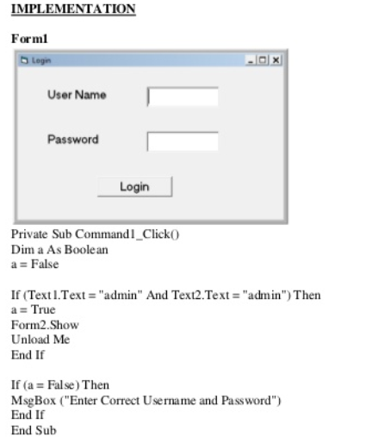

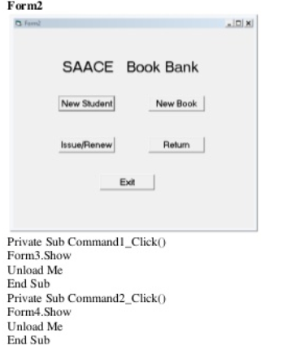

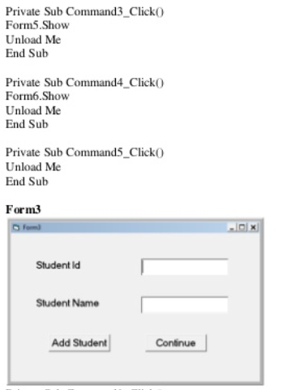

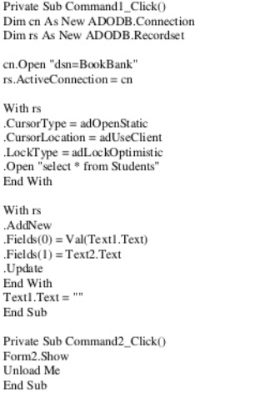

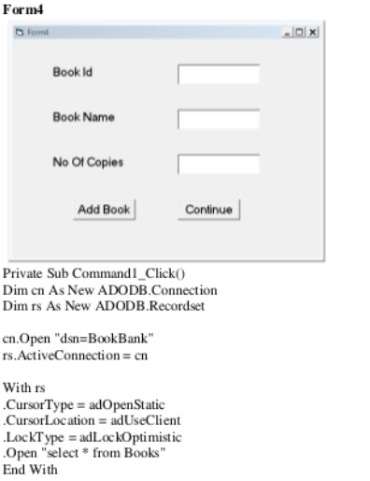

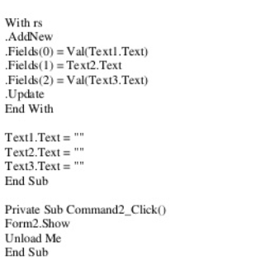

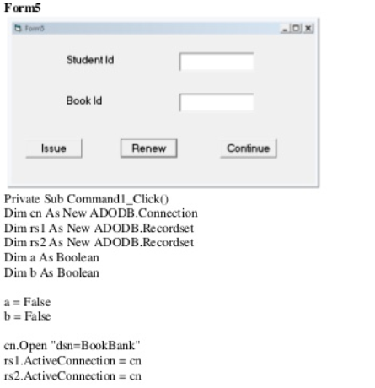

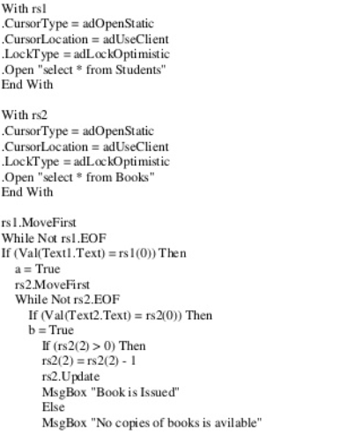

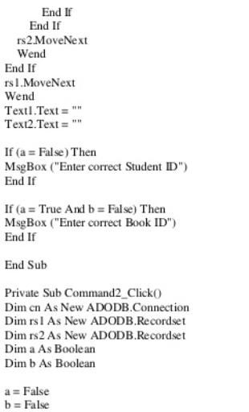

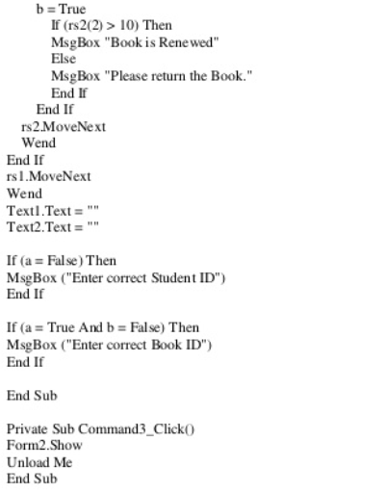

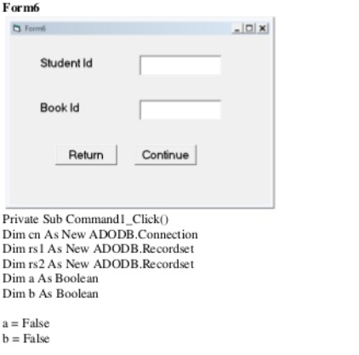

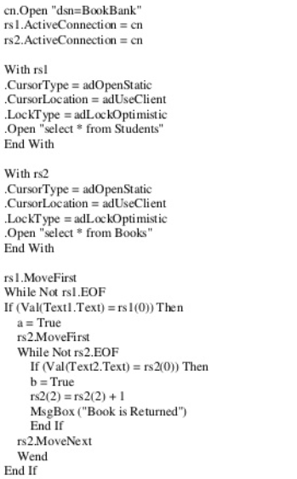

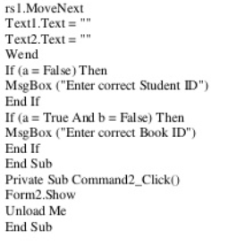

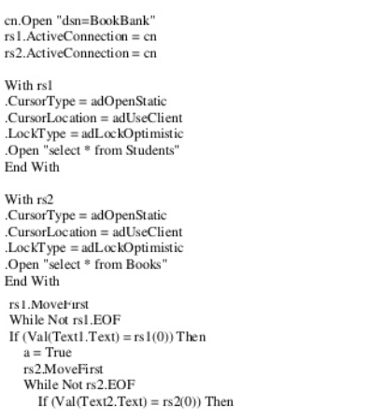

**SOFTWARE REQUIREMENT SPECIFICATION DOCUMENT**

**FOR EXAM REGISTRATION SYSTEM**

**1. Introduction:**

**1.1 Purpose of the system:**

The purpose of the exam registration system is to enable the applicants to register online for the various exams offered in Jeeth institutions effortless and user-friendly manner.By using this system manual processing is avoided and time consumed is reduced.

**1.2 Scope of the system:**

The system will be built initially as a standalone system that could be hosted anywhere.This approach will enable us to fully develop and debug the system in full before it can be integrated within any system.This system will be built to be highly available,redundant and fully secured.

**1.3 Overview of the system:**

In essence,this system provides the interface to the main registration database system.Initially,the system provides a list of various exams,once the candidates select their desired exam,the available venues and dates will be displayed out of which they can choose the date and venue convenient to them.According to their selection the form is filled and the required document must be scanned and uploaded.If the details are verified and found to be authentic the applicant proceeds to payment.

**2 General Description:**

**2.1 Product Perspective:**

Once the system is completely developed and tested it will be incorporated as part of the Jeeth institution website.This will be developed using a scripting language such as javascript and the oracle server will be used as a backend.

**2.2 Product Function:**

It involves the following steps:

1) Sign up and register

2) Upload the documents

3) Make the payment

4) Hall ticket generation

5) View results

**2.3 User Characteristics:**

The system will be used in two modules which are administrator and student modules.As both of these have different requirements they are designed to meet their needs and avoid any type of confusion.

**Administrator Module:**

* + Add and edit courses
  + Add and edit date
  + Add and edit venue
  + Add and edit mode of payment
  + View result
  + Generate report

**Applicant module:**

* + Register for an exam
  + View result

**2.4 General constraints:**

* Security:The information should be secure and there should not be any kind of malfunction.
* Reliabilty:It should keep secure all information regarding an applicant.It should work effectively in tremendous rush.
* Flexibility:The system should be able to work on other kinds of technology with little modifications.
* Efficiency:The system should not hang or lose its efficiency in any kind of worse condition.

**2.5 Hardware requirement:**

* Pentium 4
* 200 MB hard disk space
* 512 MB RAM

**Software requirements:**

* Browser IE6 or above or google chrome or Mozilla firefox
* Microsoft .NET framework version 2.0 or above

**3 Specific Requirements:**

**3.1 Functional requirements:**

* Data must be entered completely before a form is submitted
* The system will limit access to authorized users
* The database will have a functional audit trail

**3.2 Performance requirements:**

* The system is required a fair amount of speed while browsing through the catalogue and presenting different possibilities.
* When the system is disconnected or frozen due to over access at the same time,it should save all the processes of the users.
* The system should be able to manage all the information from the database.

**3.3 Reliability:**

The reliability of the system is directly linked to the level of update of the documents to which it is correlated,such as the catalogue or the student database. The system and the external documents must be updated constantly according to the necessities of the stakeholders.

**3.4 Safety requirements:**

* Every student must have secure and private access to his/her data.
* Data integrity should be assured by limiting access to the database and by appropriate synchronization and back-up functionalities.
* The system will develop a security system that will reduce to the minimum the possibility of corruption from systems and/or humans.

**RISK MANAGEMENT**

|  |  |  |  |  |  |
| --- | --- | --- | --- | --- | --- |
| **S.**  **no** | **Risk** | **Category** | **Probability** | **Impact** | **RMMM** |
| 1. | Database Connectivity | Technology to be built | 5% | Catastrophic | Test the software regularly and take backups of the data at periodic intervals |
| 2. | Document uploading problems | Stakeholder characteristics | 20% | Marginal | Raise a pop-up window indicating the error and requesting to redo the operation with appropriate file type |
| 3. | Requirement understanding | Process definition | 10% | Catastrophic | Analyze and understand the project completely, meet up with the customer at regular intervals and get feedback. |
| 4. | Project not meeting deadline | Staff size and experiment/ product size | 15% | Critical | Have back-up staff in case of emergency and spend less time in the planning stage. |
| 5. | Project cost | Development environment/  Process definition | 25% | Critical | Allocate resources at each stage of the project efficiently, place maximum bounds on the cost estimate. |
| 6. | Continuous requirement change | Stakeholders characteristics | 10% | Marginal | High change threshold, information hiding, incremental development. |
| 7. | Real-time performance shortfalls | Technology to be built/ development environment | 5% | Critical | Simulation, benchmarking, modeling, prototyping, instrumentation, tuning. |
| 8. | Security  (virus attacks) | Business impact | 20% | Catastrophic | Build strong firewalls and embed anti-virus software |
| 9. | Unauthorized access of data | Business impact | 8% | Marginal | Passwords should be combinations of letters, digits and special characters and users should be notified about each login. |

**GANTT CHART**

**USE CASE DIAGRAM**

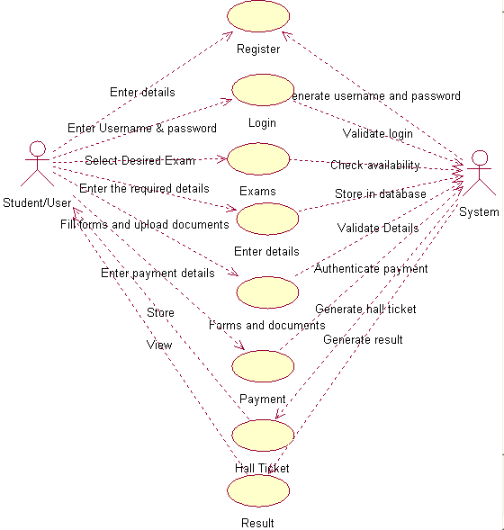

**CLASS DIAGRAM**

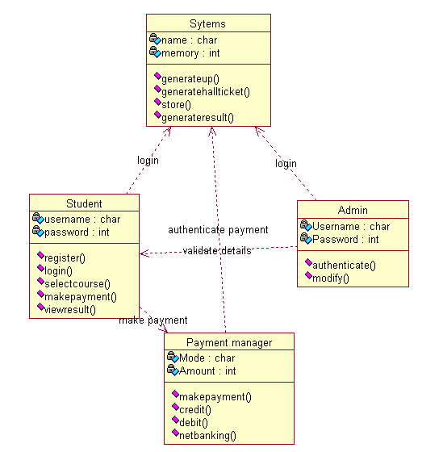

**ACTIVITY DIAGRAM**



**SEQUENCE DIAGRAM**



**COLLABORATION DIAGRAM**



**STATE CHART DIAGRAM**



**LOGICAL ARCHITECTURE DIAGRAM**



**COMPONENT DIAGRAM**



**DEPLOYMENT DIAGRAM**



**IMPLEMENTATION**

**Form1**

Enter user name and password to login or register.

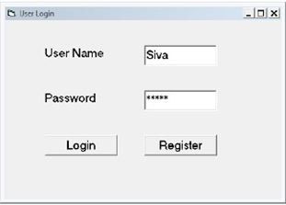

Private Sub Command1_Click()

Dim cn As New ADODB.Connection

Dim rs As New ADODB.Recordset

Dim a As Boolean

a = False

cn.Open "dsn=exam"

rs.ActiveConnection = cn

With rs

.CursorType = adOpenStatic

.CursorLocation = adUseClient

.LockType = adLockOptimistic

.Open "select * from Students"

End With

If (a = False) Then

MsgBox ("Enter Correct UserName and Password")

End If

End Sub

Private Sub Command2_Click()

Form2.Show

Unload Me

End Sub

**Form2**

Enter the required details to register for the exam.

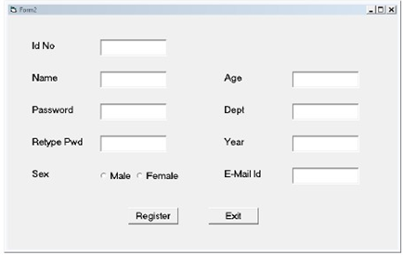

Private Sub Command1_Click()

Dim cn As New ADODB.Connection

Dim rs As New ADODB.Recordset

cn.Open "dsn=Exam"

rs.ActiveConnection = cn

If (Text3.Text = Text4.Text) Then

With rs

.CursorType = adOpenStatic

.CursorLocation = adUseClient

.LockType = adLockOptimistic

.Open "select * from Students"

End With

With rs

.AddNew

.Fields(0) = Val(Text1.Text)

.Fields(1) = Text2.Text

.Fields(2) = Text3.Text

If (Option1 = True) Then

.Fields(3) = Option1.Caption

End If

If (Option2 = True) Then

.Fields(3) = Option2.Caption

End If

.Fields(4) = Val(Text5.Text)

.Fields(5) = Text6.Text

.Fields(6) = Text7.Text

.Fields(7) = Text8.Text

.Update

MsgBox ("Registration Success. Please Login")

Form1.Show

Unload Me

End With

Else

MsgBox ("Password doesn't match")

End If

End Sub

Private Sub Command2_Click()

Unload Me

End Sub

**Form3**

Register Exam: This option is to register for an exam.

Enquiry Exam: This option will let the applicant know about the results of a particular exam.

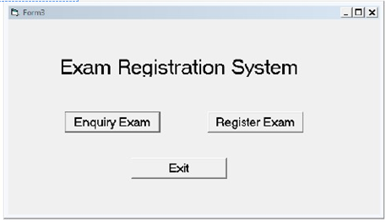

Private Sub Command1_Click()

Form4.Show

Unload Me

End Sub

Private Sub Command2_Click()

Form5.Show

Unload Me

End Sub

Private Sub Command3_Click()

Unload Me

End Sub

**Form4**

Private Sub Command1_Click()

Form3.Show

Unload Me

End Sub

Private Sub Text1_Change()

Dim cn As New ADODB.Connection

Dim rs As New ADODB.Recordset

cn.Open "dsn=exam"

rs.ActiveConnection = cn

This form is for making the payment for the exam.

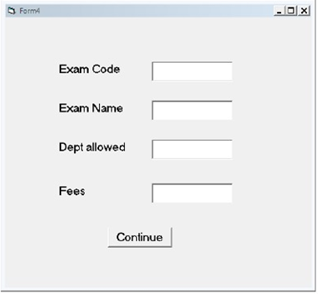

With rs

.CursorType = adOpenStatic

.CursorLocation = adUseClient

.LockType = adLockOptimistic

.Open "select * from Exams"

End With

rs.MoveFirst

While Not rs.EOF

If (Val(Text1.Text) = rs(0)) Then

Text2.Text = rs(1)

Text3.Text = rs(2)

Text4.Text = rs(3)

End If

rs.MoveNext

Wend

End Sub

**Form 5:**

After the payment of fees this form will appear where the student is finally registered for the exam.

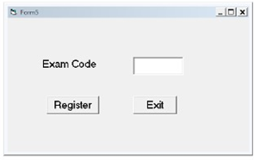

Private Sub Command1_Click()

Dim cn As New ADODB.Connection

Dim rs As New ADODB.Recordset

cn.Open "dsn=Exam"

rs.ActiveConnection = cn

With rs

.CursorType = adOpenStatic

.CursorLocation = adUseClient

.LockType = adLockOptimistic

.Open "select * from Exams"

End With

rs.MoveFirst

While Not rs.EOF

If (Val(Text1.Text) = rs(0)) Then

rs(4) = rs(4) + ", " + Form1.Text1.Text

rs.Update

a = True

MsgBox "Exam Applied"

End If

rs.MoveNext

Wend

If (a = False) Then

MsgBox ("Enter correct Exam ID")

End If

End Sub

Private Sub Command2_Click()

Unload Me

End Sub

**SOFTWARE REQUIREMENTS SPECIFICATION DOCUMENT**

**FOR STOCK MAINTENANCE SYSTEM**

**1 INTRODUCTION:**

This software specification documents full set of features and functions for online stock maintenance system that is maintained in a company website. In this we give specification about the customer orders. It tells the usability, reliability defined in use case specification.

**1.1 PURPOSE OF THE SYSTEM:**

The purpose of the stock maintenance system is to maintain the stock (i.e) to maintain the stock in a precise manner.

**1.2 SCOPE OF THE SYSTEM:**

The scope of this stock maintenance system is to maintain the stock for supermarkets, retailers and suppliers individually.

**1.3 OVER VIEW OF THE SYSTEM:**

The overview of the project is to design an online tool for the recruitment process which eases the work for the customer as well as the companies. The shopkeepers can create their own forms in a way that they would like their database to look like.

**2 GENERAL DESCRIPTION:**

**2.1 PRODUCT PERSPECTIVE:**

* This product requires a web browser.
* This program will not be dependent on any other software and is not a component of another program.
* This program does not need any new hardware.

**2.2 PRODUCT FUNCTION:**

Its function is to maintain the record of stock, billing, details offline, out of the product and their current stock positions with the company.

**USER INTERFACE:**

A convenient GUI will provide users with the ability to quickly enter the information from the incoming orders from the supermarkets and to output the invoices reflecting the outgoing flow of goods supplied to the supermarkets.

**2.3 GENERAL CONSTRAINTS:**

* The product consumes that all deliveries from warehouse to supermarket are successfully completed and there is no loss of items on the way.
* It assumes that all suppliers have enough stock.
* Specific book keeping and accounting regulations reflecting the current laws and regulations will have to be programmed when updated.

**3 HARDWARE REQUIREMENTS:**

* Processor : Pentium IV 2Ghz
* RAM: 2Gb RAM
* Monitor: 15’ inch coloured
* Keyboard
* Mouse

**SOFTWARE REQUIREMENTS:**

* Operating : Windows XP
* Developing tool: Visual Basic 6.0
* Database: MS Access

**4 SPECIFIC REQUIREMENTS:**

**4.1 FUNCTIONAL REQUIREMENTS:**

A functional requirement defines a function of a software system on its component.

* Accepting orders from supermarkets
* Responding to orders from supermarkets
* Getting supermarkets billed
* Sending goods to supermarkets
* Ordering from suppliers
* Receiving payment
* Paying suppliers
* Conducting daily and weekly sales analysis

**4.2 PERFORMANCE REQUIREMENTS:**

All pages should be loaded within 3 seconds or less assuming a broadband connection on the clients side. Therefore, response time for transaction will be less. The system should support as many as 50 online users simultaneously with negligible response delay.

**4.3 SAFETY REQUIREMENTS:**

* The system shall automatically log out after a period of inactivity.
* The system shall not leave any cookies on the customer’s computer containing any of the user’s confidential information.
* Systems back-end databases shall be encrypted.

**4.4 RELIABILITY:**

The system should be available at all times except for monthly maintenance of not more than 10 minutes. The system backup onto a second server will be performed during the maintenance time as well as once daily(midnight) and system recovery will only be executed as necessary. In addition the secondary server will be prepared to help recover in the event of hardware failure.

**USE CASE DIAGRAM**



**CLASS DIAGRAM**



**ACTIVITY DIAGRAM**



**SEQUENCE DIAGRAM**

:Customer

:System

:Stock holder

:Shop owner

Enter the stock details in system

Update the database

Purchase items

Enter the items in the system

Calculate bill

Update the stock and checks for threshold value

If value above threshold, generates receipt

Gives the receipt

Makes payment

Gives items

If value below threshold, send sms

Places order accordingly

Delivers the stock

Pays amount on receiving stock

Updates the new stock details

**COLLABORATION DIAGRAM**



**STATE CHART DIAGRAM**



**LOGICAL ARCHITECTURE**



**COMPONENT DIAGRAM**

Oracle

sms.exe

<<Executable>>

Apache Tomcat

<<Server>>

JSP

<<Component>>

**DEPLOYMENT DIAGRAM**



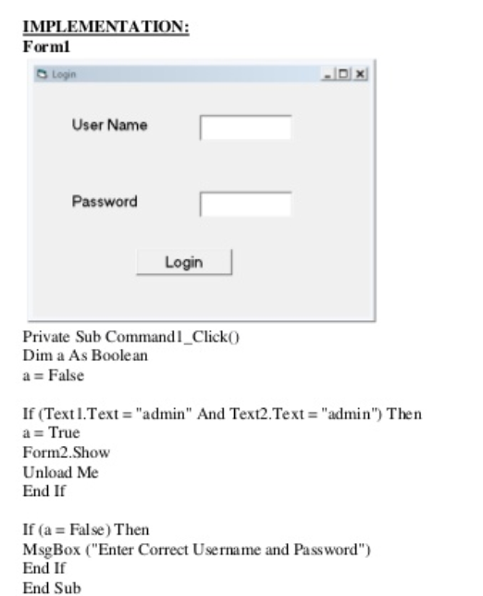

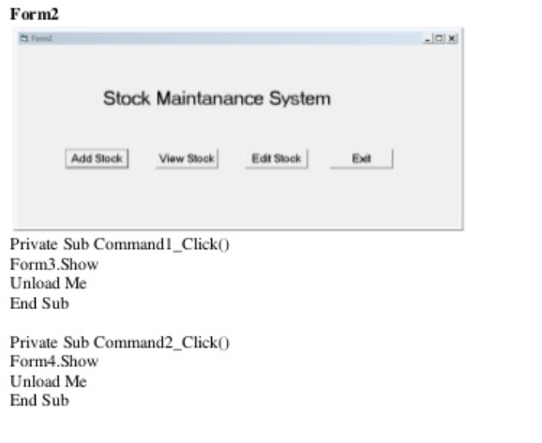

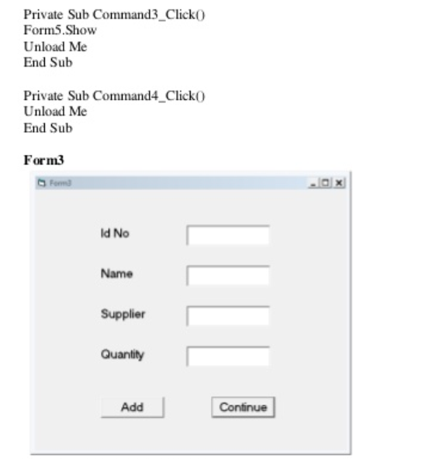

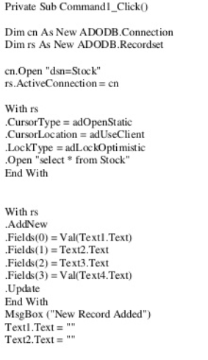

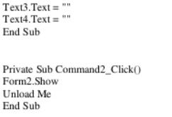

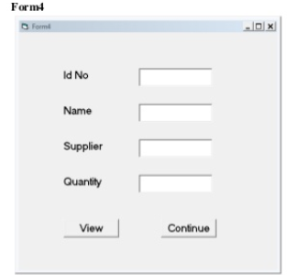

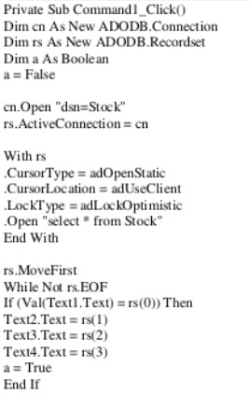

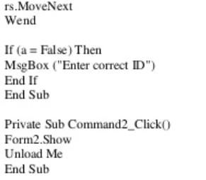

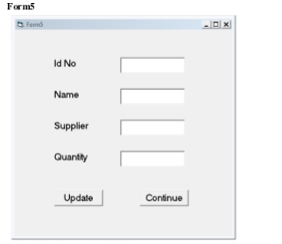

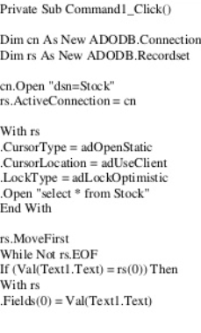

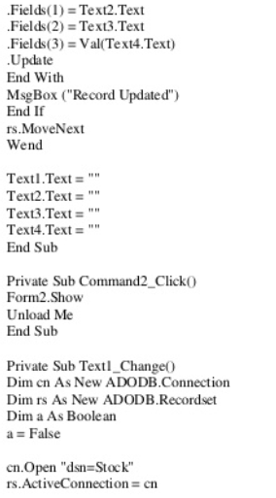

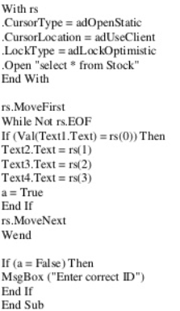

**SOFTWARE REQUIREMENTS SPECIFICATION DOCUMENT**

**FOR ONLINE COURSE RESERVATION SYSTEM**

**1 Introduction:**

**1.1 Purpose of the system:**

The main purpose of the system is to provide a clear view of the requirements of online course reservation system to the developer.This project aims at developing the online system for students to learn online.

**1.2 Scope of the system**:

The scope of the software product developed involves paid service to the students to select and learn a restricted number of courses that are being offered.It involves a very simple registration procedure to be done by the student while being guided by a mentor through the course.

**1.3 Overview of the system**:

The overview of the system explains in detatil the various software and hardware requirements for the specification and also elaborates on the constraints involved in the system.

**2 General description:**

**2.1 Product perspective:**

The system gives an overall description about the available course that a student can opt to learn and professor can prefer to teach. The system provides login facility to the students .The system checks whether the user have the required qualification to register and to view further details on course availability.It allows the administrator to create the catalog and store it in the database.

**2.2 Product function:**

The main functions include

1.Entering the student details into the database

2. Offering the chosen course to the student.

3.Receiving payment from the student.

**2.3 User Interface:**

A very interactive GUI is provided to the student and the staff.It prompts the factors to give the required input for each activity of the system.

**2.4 General Constraints:**

1.Product Limitation

2.Parallel operation not applicable

3.Data Redudancyand use of Special/Blank characters must be avoided during registration.

**3 Hardware Requirements:**

Processor:Pentium 4 2GHZ

RAM: 2GB RAM

Monitor:15 inch coloured

Keyboard

Mouse

**Software Requirements:**

Windows XP

Oracle 6

MYSQL

Netbeans IDE

**4 Functional Requirement:**

1.Functional requirement defines the function of a software system on its component.

2.Accepting the student details.

3.Checking the availability of course.

4.Verifying the document attached.

5. Receiving payment

5 **Performance Requirements:**

1.Multi users can access the software at any given time.

2.When the system is disconnected it should store the process being carried out.

3.It should accept and process the data in fair amount of time.

**6 Safety Requirement:**

1.Payment transactions made at highly secure.

2.It keeps the data of the document updated confidential.

3.It reduces complexity involved in maintaining software.

7. **Reliability:**

The factors for establishing reliability are

1.The user cannot use the software with no valid id.

2.The staff qualifications are tested and hence a reliable service is offered.

**USECASE DIAGRAM:**

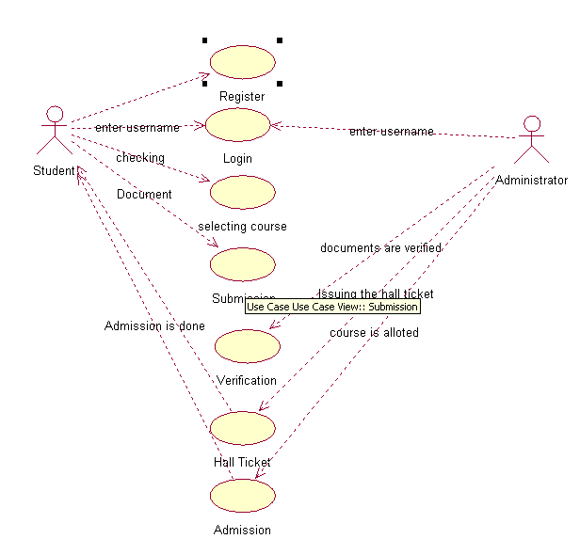

**Class Diagram:**

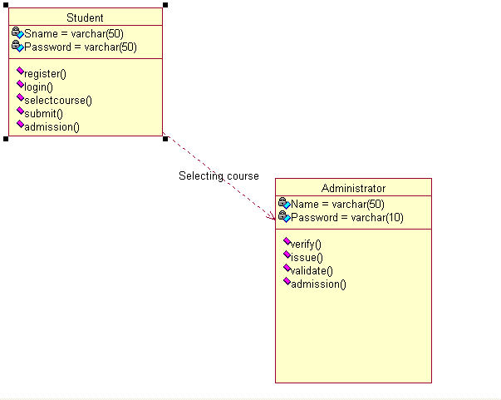

**ACTIVITY DIAGRAM**

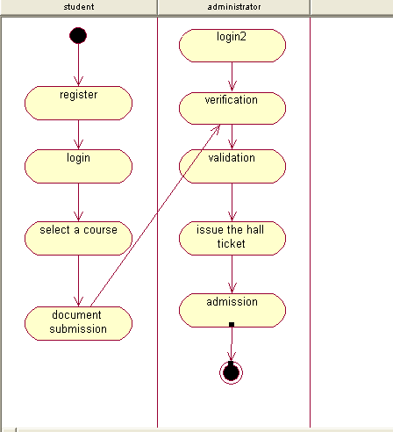

**SEQUENCE DIAGRAM**

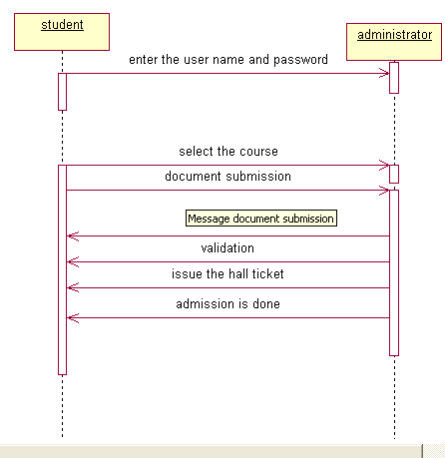

**COLLABORATION DIAGRAM**

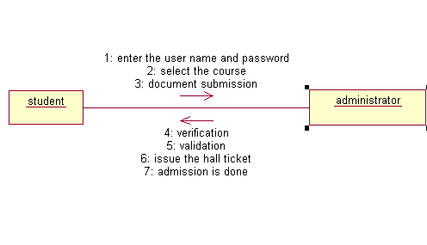

**State Chart Diagrams**

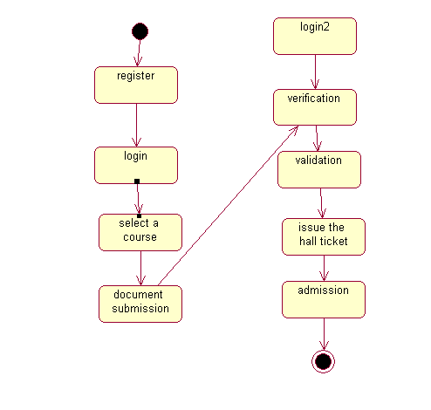

**LOGICAL ARCHITECTURE**



**COMPONENT DIAGRAM**



**DEPLOYMENT DIAGRAM**



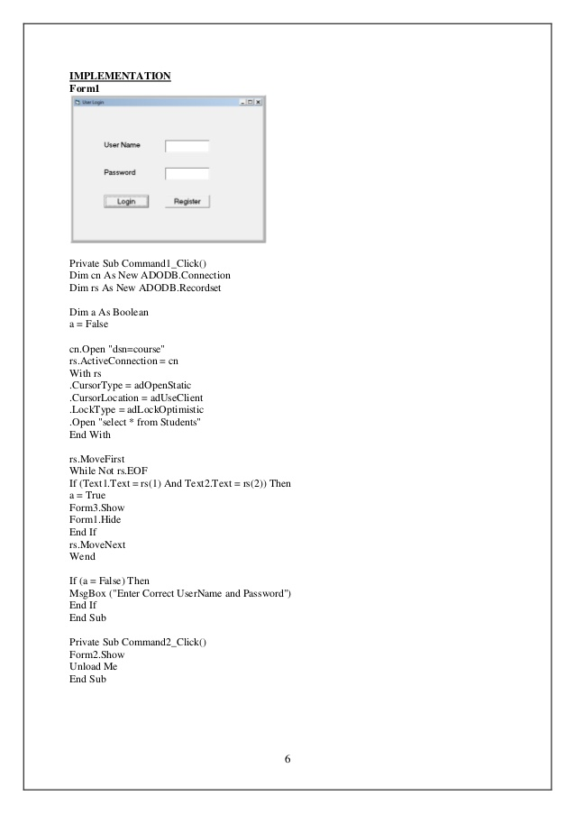

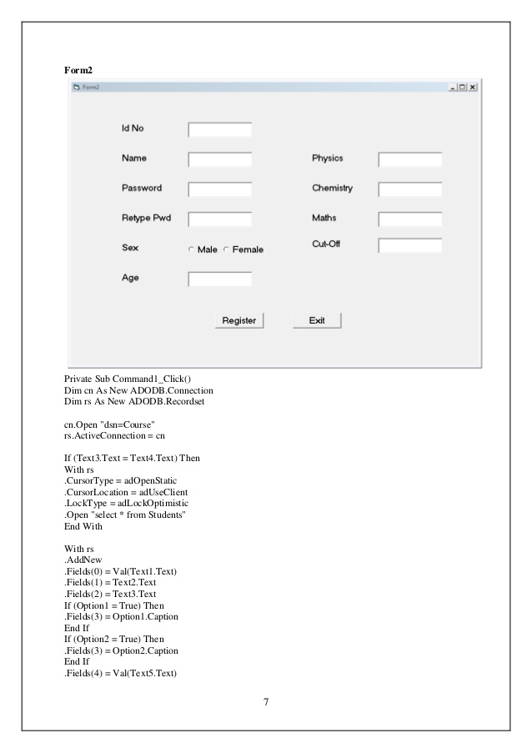

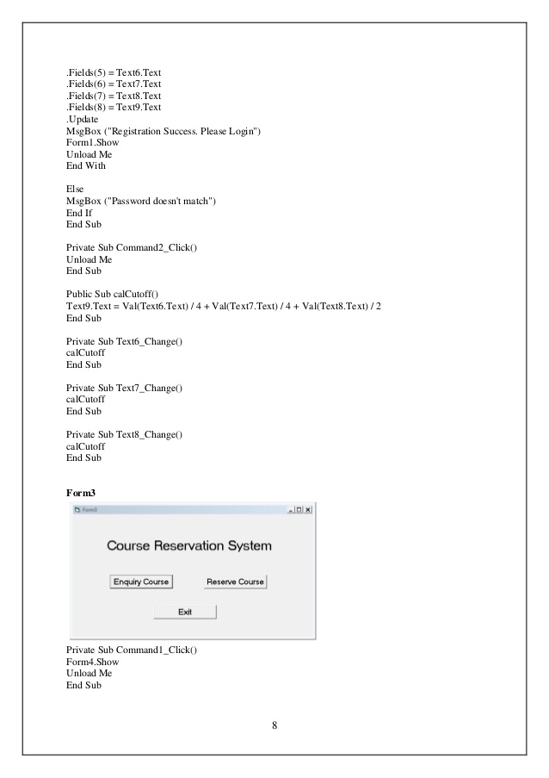

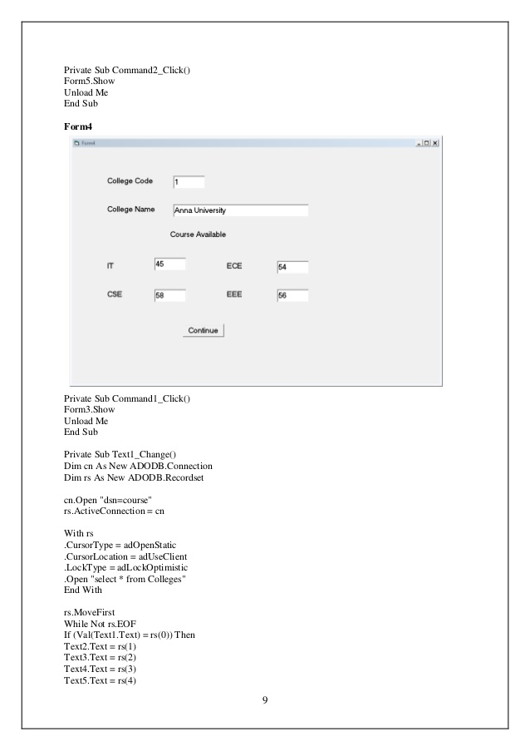

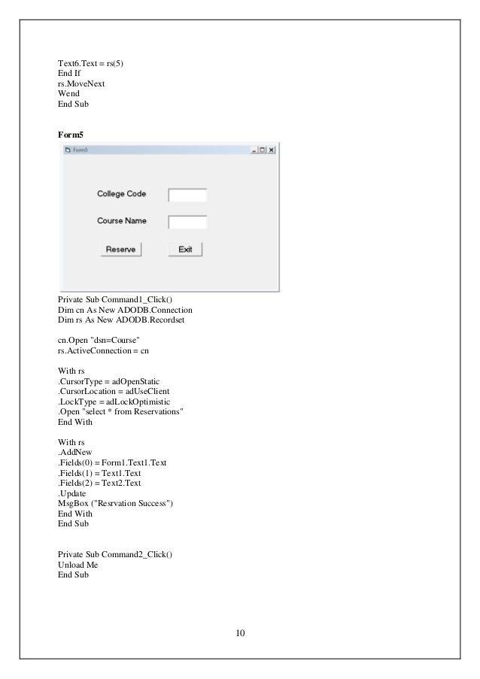

**SOFTWARE REQUIREMENTS SPECIFICATION DOCUMENT**

**FOR CREDIT CARD PROCESSING**

**1 Introduction :**

* Purpose of the system
* Scope of the system
* Overview of the system

**2 General description :**

* Product perspective
* Product function
* User Interface
* General constraints
* Hardware Requirements
* Software Requirements

**3 Specific Requirements :**

* Functional Requirements
* Performance Requirements
* Safety Requirements
* Reliability .

**1 Introduction :**

**1.1 Purpose of the system :**

The purpose of the system is to allow customers perform safe and secure transactions , easy ,low cost , remote access to the accounts outside of regular business hours.

**1.2 Scope of system :**

The system can be use in various is to provide better customer services,such as safe and reliable transactions. Banks should be able to perform multiple simultaneous transactions .Credit processing system can be implemented in bank ATM's ,shopping malls,stores etc.

**1.3 Overview of the system:**

The overview of the system is to build a credit card processing system that enables/helps customers,anytime.

**2 General description:**

**2.1 Product perspective:**

The product perspective is to build servers that stores the transaction information made by every customer by making proper updations after each transaction. To support multiple multiple transactions ,the credit card processing system is aimed towards the segments of people. This system serves the customers providing them cash free environment for purchase ,further it provides shopkeepers an opportunity to provide customers an easy purchasing experience .This system requires the customer to hold a card and requires internet connection at retail outlets.

**2.2 Product functions:**

A credit card processing system must support the following cases.

1.Class of use case:use case related to authorization,transaction,product delivery.

2.Use cases:login,submit order,transfer funds,product delivery.

**2.3 User Interface:**

The principle actors in the credit card processing system are customer,seller, and the system. The seller would require knowledge regarding the usage of the system and the end user would only need to carry a card.

**2.4 General constraints:**

The general constraints for the full working of a credit card processing system are interest connections as it is a multi user,multi server system as the working depends on the availability of server databases at all times.

**2.5 Hardware requirements:**

Processor:I6

harddisk:1 TB

Ram:2GB

**Software requirements:**

OS:windows 8

mysql

Java NetBeans 6.5.1

**3 Specific requirements:**

**1.1 Functional requirements**:

The functional requirements can be done described by giving various use cases.

Case 1:login

->customer presents a card to pay for the products.

->The merchant processes the card and sends a request to the merchant bank.

->The card issuer approves/declines request.

->If the basic flow of validate card fails the the case ends with a failure condition.

Case 2:Submit order:Pre-condition case 1 success

Once the customer is logged in,they can browse products check availability,select product for purchase

->after the product is selected the system displays information about the product.

Then order is submitted,validated the system notifies the customer with success message.

->The case fails if the order is invalid or the user does not login succesfully or if the product is not available.

Case 3:transfer fund: pre-condition ,the customer must have an account:

->The merchant sends a request to the request to the customers bank account.

->The credit card network pays the merchant bank and debits the card issuer account.

->The card issuer sends a monthly statement to the card holder for settlement.

->the case fails if the customer does not have enough money.

**3.2 Performance requirement:**

The system should run on a 500MHz,64MB machine and 90% of the responses should be within 2 seconds the transaction should be error here.

**3.3 Safety requirement:**

The files in which the information regarding users nad settlers should be secured against malicious deformations ,unauthorized users and other malpractices .The data should not become corrupted in case of system crash or power failure.

**3.4 Reliability:**

The system should be reliable ,error-free ,secure and should be fault tolerant i.e It should be durable even during a system crash or system failure. The system should not lose data .The transactions must be error free and responses must be sent and received within the specified time span.

**USECASE DIAGRAM**



**CLASS DIAGRAM**



**ACTIVITY DIAGRAM**



**SEQUENCE DIAGRAM**



**COLLABORATION DIAGRAM**



**COMPONENT DIAGRAM**



**LOGICAL ARCHITECTURE** 

**STATE CHART DIAGRAM**



**IMPLEMENTATION:**

public class CreditFrame1 extends javax.swing.JFrame {

public CreditFrame1() {

initComponents();

    }

int cost;

int used;

 private void Submit1ActionPerformed(java.awt.event.ActionEvent evt) {                            String name=t1.getText();

  int number=Integer.parseInt(t2.getText());

  cost=Integer.parseInt(t3.getText());

  CreditFrame2.setVisible(true);

    }

private void submit2ActionPerformed(java.awt.event.ActionEvent evt) {                           String ownername=t4.getText();

  int cardno=Integer.parseInt(t5.getText());

  int limit=Integer.parseInt(t7.getText());

   used=Integer.parseInt(t8.getText());

  if(((limit-used)-cost)>=0)

   l1.setText("Transaction Successful ");

   else

    l1.setText("Transaction Failed");

    }

 public static void main(String args[])

{

java.awt.EventQueue.invokeLater(new Runnable()

{

public void run()

{

new CreditFrame1().setVisible(true);

   }

   });

  }

 private javax.swing.JFrame CreditFrame2;

    private javax.swing.JButton Submit1;

    private javax.swing.JLabel jLabel1;

    private javax.swing.JLabel jLabel10;

    private javax.swing.JLabel jLabel2;

    private javax.swing.JLabel jLabel3;

    private javax.swing.JLabel jLabel4;

    private javax.swing.JLabel jLabel5;

    private javax.swing.JLabel jLabel6;

    private javax.swing.JLabel jLabel7;

    private javax.swing.JLabel jLabel8;

    private javax.swing.JPanel jPanel1;

    private javax.swing.JPanel jPanel2;

    private javax.swing.JPanel jPanel3;

    private javax.swing.JTextField l1;

    private javax.swing.JButton submit2;

    private javax.swing.JTextField t1;

    private javax.swing.JTextField t2;

    private javax.swing.JTextField t3;

    private javax.swing.JTextField t4;

    private javax.swing.JTextField t5;

    private javax.swing.JTextField t7;

private javax.swing.JTextField t8;

 }

SCREENSHOTS

The cashier enters the product details into the system .

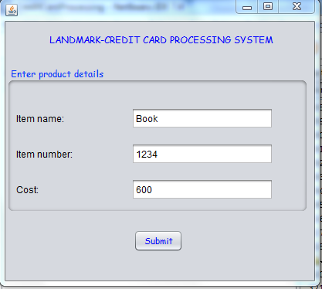

The credit card details are entered and the transaction is checked for its validity .

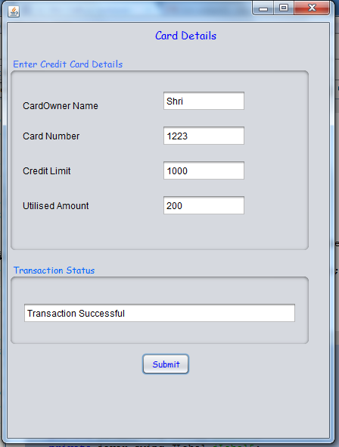

The product details are entered by the cashier .



The transaction is checked for its validity and invalid transactions are declined .

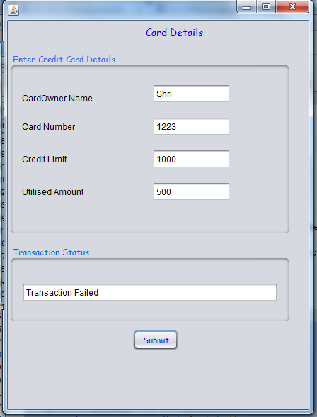

**SOFTWARE REQUIREMENT SPECIFICATION DOCUMENT**

**FOR EBOOK MANAGEMENT SYSTEM**

**1 INTRODUCTION:**

E-book management system gives an idea about how eBooks are maintained in particular. EBooks that are to be purchased, the eBooks that are sold are maintained here. Further, some additional details of the current eBook list that is available in that particular website is also given. In this project the eBook management system is done in an authorized way.

**1.1 PURPOSE**:

The purpose of eBook management system is to store and sell the books in a website effectively.

**1.2 SCOPE OF THE PROJECT:**

The scope of this eBook management is to maintain the book details after the purchase a list of remaining books available in the same book type.

The software provides the visitor, customer and administrator an easy and efficient way to buy and manage books online.

Software provides the following facilities to customer:

1. Facilitates easy shopping online.
2. Provides information about the products in categories.
3. Provides e-mail facility for future correspondence.
4. Provides backup facility.

Software provides the following facilities to the merchant:

1. Manages the transportation of hardcopy of book.
2. Look after the payment methods.

**1.3 OVERVIEW:**

The overview of this project is to store the information about the eBooks and update the eBook list for each organization, which is using this system, keeps track of all systems.

**2 GENERAL DESCRIPTION:**

**2.1 PRODUCT PERSPECTIVE:**

A product requires a web browser. EBook management system is about giving an idea about how eBooks are maintained in particular. EBooks that are to be purchased, the eBooks that are sold are maintained. It is done in an authorized way.

**2.2 PRODUCT FUNCTION:**

The main functionality of this project eBook management system is to store and sell eBooks for a website. The member should be provided with the updated information about the books catalog.The member is given a provision to check his account information and change the account information any time in the given valid period.

The Website administrator is provided with interfaces to add/delete the books available in the book catalog.

**2.3 USER INTERFACE:**

The user interface makes the eBook management system to be efficient. That is, the system will help the admin to maintain stock details easily and helps to handle the stocks effectively. The system should be user friendly.

**2.4 HARDWARE REQUIREMENTS:**

1. Processor-Intel Pentium IV.2.0 GHz
2. Hardware (40GB)
3. RAM-512Mb
4. DVDRAM-1nos.

**SOFTWARE REQUIREMENTS:**

1. Operating system-Windows XP/Vista
2. Front end tool-Rational Rose enterprise suite
3. Backend tool-Oracle 10i

**3 SPECIFIC REQUIREMENTS:**

**3.1 FUNCTIONAL REQUIREMENTS:**

Functional requirements are those that refer to the functionality of the system that is , the services that are provided to the website which maintains eBooks in the online database.

1. Register: Enter details in application form.
2. Login: Enter username and Password
3. Search: Search book by attribute
4. Buy: Download softcopies and order the hardcopy
5. Payment: Pay for books in different method.
6. Update: Update user details.

**3.2 PERFORMACE REQUIREMENTS:**

The capability that the system performs on the whole will be efficient and reliable without any error occurrence. It also performs and describes the capability to store without any error and performing it efficiently.

**3.3 SAFETY REQUIREMENTS:**

The user details should be made available in the database and must be updated every time a book is brought or cancelled or some kind of payment takes place to prevent errors.

**3.4 RELIABILITY:**

The eBook management system should be able to serve the customers with correct information and day-to-day update of eBook list details.

**USECASE DIAGRAM**



**CLASS DIAGRAM**



**ACTIVITYDIAGRAM **

**SEQUENCE DIAGRAM**



**COLLABORATION DIAGRAM**



**STATE CHART DIAGRAM**



**LOGICAL ARCHITECTURE**



**COMPONENT DIAGRAM**

e-book.exe

<<Exectable>>

Apache Tomcat

<<Server>>

JSP

<<Component>>

Oracle

**DEPLOYMENT DIAGRAM**

:HCL PC

<<client workstation>>

:e-book.exe

<<artifact>>

:Dell PowerEdge 3600

<<server>>

:Apache 2.1

<<web server cluster>>

Admin:Tomcat 6

<<servlet container>>

:Dell PowerEdge 3400

<<server>>

:Windows XP

Paper selection<<OS>>

:Postgre SQL 10

<<Database>>

SOAP/HTTP

SQL

**IMPLEMENTATION**

**Form1**

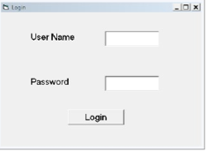

Private Sub Command1_Click()

Dim a As Boolean

a=False

If(Text1.Text=”admin” And Text2.Text=”admin”) Then

a=True

Form2.Show

Unload Me

End If

If(a==False) Then

MsgBox(“Enter Correct Username and Password”)

End If

End Sub

**Form2**

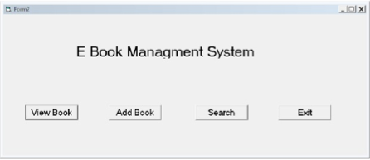

Private Sub Command1_Click()

Form3.Show

Unload Me

End Sub

Private Sub Command2_Click()

Form4.Show

Unload Me

End Sub

Private Sub Command3_Click()

Form5.Show

Unload Me

End Sub

Private Sub Command4_Click()

Unload Me

End Sub

**Form3**

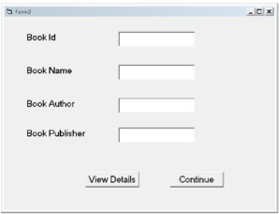

Private Sub Command1_Click()

Dim cn As New ADODB.Connection

Dim rs As New ADODB.Recordset

Dim a As Boolean

a=False

cn.Open “dsn=ebook”

rs.ActiveConnection=cn

With rs

CursorType = adOpenStatic

CursorLocation =adUseClient

LockType =adLockOptimistic

Open “select * from Details”

End With

rs.MoveFirst

While Not rs.EOF

If(Val(Text1.Text)=rs(0)) Then

Text2.Text = rs(1)

Text3.Text = rs(2)

Text4.Text = rs(3)

a=True

End If

rs.MoveNext

Wend

If(a==False) Then

MsgBox (“Enter correct ID”)

End If

End Sub

Private Sub Command2_Click()

Form2.Show

Unload Me

End Sub

**Form4**

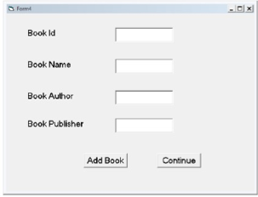

Private Sub Command1_Click()

Dim cn As New ADODB.Connection

Dim rs As New ADODB.Recordset

cn.Open “dsn=ebook”

rs.ActiveConnection =cn

With rs

CursorType = adOpenStatic

LockType = asLockOptimistic

Open “select * from Details”

End With

With rs

AddNew

Fields(0) = Val(Text1.Text)

Fields(1) = Text2.Text

Fields(2) = Text3.Text

Fields(3) = Text4.Text

Update

End With

Text1.Text = “ “

Text2.Text = “ “

Text3.Text = “ “

Text4.Text = “ “

End Sub

Private Sub Command2_Click()

Form2.Show

Unload Me

End Sub

**Form5**

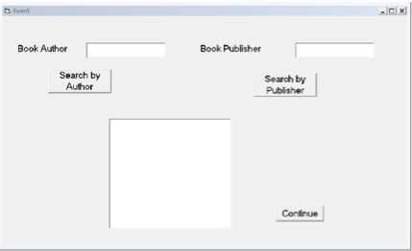

Private Sub Command1_Click()

Dim cn As New ADODB.Connection

Dim rs As New ADODB.Recordset

Dim a As Boolean

a=False

cn.Open “dsn=ebook”

rs.ActiveConnection =cn

With rs

CursorType = adOpenStatic

CursorLocation = adUseClient

LockType =adLockOptimistic

Open “select * from Details”

End With

rs.MoveFirst

While Not rs.EOF

If(Text1.Text = rs(2)) Then

Text3.Text = Text3.Text + Str$(rs(0)) + “,”

Text3.Text = Text3.Text + rs(1) + “,”

Text3.Text = Text3.Text + rs(3) + “,”

a=True

End If

rs.MoveNext

Wend

If(a==False) Then

MsgBox(“Enter correct Author name “)

End If

End Sub

Private Sub Command2_Click()

Dim cn As New ADODB.Connection

Dim rs As New ADODB.Recordset

Dim a As Boolean

a=False

cn.Open “dsn = ebook “

rs.ActiveConnection = cn

With rs

CursorType = adOpenStatic

CursorLocation = adUseClient

LockType = adLockOptimistic

Open “select * from Details”

End With

rs.MoveFirst

While Not rs.EOF

If(Text2.Text = rs(3)) Then

Text3.Text = Text3.Text + Str$(rs(0)) + “,”

Text3.Text = Text3.Text + rs(1) + “ , “

Text3.Text = Text3.Text + rs(2) + “ , ”

a=True

End If

rs.MoveNext

Wend

If(a==False) Then

MsgBox(“Enter correct Publisher Name”)

End If

End Sub

Private Sub Command3_Click()

Form2.Show

Unload Me

End Sub

**SOFTWARE REQUIREMENTS SPECIFICATION DOCUMENT**

**FOR RECRUITMENT SYSTEM**

**1 Introduction:**

This is the project to help jobseeker to look for job. To help company HR team to look for candidate for vacant positions in their respective company. Nowadays there are many graduates/post graduates who are seeking for the job. But they may not know about the companies, new trends of companies. Many companies require employees. But they also cannot get the proper candidates for their company .To recruit proper candidate in the proper place we designed online recruitment system.

**1.1 Purpose of the system:**

The recruitment and selection is the major function of the human resource department and recruitment process is the first step towards creating the competitive strength and the recruitment strategic advantage for the organizations. Recruitment process involves a systematic procedure from sourcing the candidates to arranging and conducting the interviews and requires many resources and time.

**1.2 Scope of the system:**

It provides the information about the jobseekers to the industries. Company can get the information about the proper candidate according to its requirement. Inform the jobseekers for vacancies in the company/interview session in the companies. It provides the information to the jobseekers about the new trends in the industrial area. To analyze the recruitment policy of the organization and to provide a systematic recruitment process. It extends to the whole organization. It covers corporate office, sites and works appointments.

**1.3 Over all description of the system:**

The following description gives the general factors that affect system and its requirements. Candidate should finish his/her degree and should have proper certificate while applying for job and the candidate should satisfy the eligibility criteria. The resume should be in the form what that company specified while advertising.

The HR has the full permission to select or reject the candidate for interview. If the candidate is selected for the particular job means all details about the candidate will be added to the company database and the modification can also be done.

**1.4 Overview:**

This SRS document contains many use case diagram and description about all use case diagrams have been included in this document. It also gives the functional and nonfunctional requirement.SRS includes two sections general description and specific requirements. General description includes characteristics of the users of this project, the product hardware and data requirement of the product.

**2 General description:**

This software system reduce agency and processing costs, increase speed to hire, improve productivity and the candidate quality.

**2.1 Product perspective:**

HR and Candidate play a major role in the recruitment process. The necessary details of the candidate have to be submitted to the HR Verification has been done by the HR Selected candidate should be call to Interview.HR intimates the selected candidate. Finally Candidates accept or reject his offer letter. Perspective’s new recruitment module allows candidates to be easily matched to appropriate vacancies via a comprehensive skill, experience and post code matching tool. The tool allows your organization to promote vacancies and easily match suitable candidates by looking at prior attainment as well as having a comprehensive post code matching tool for easy screening of candidate suitability.

**2.2 Product function:**

Candidate who apply for job register his/her name in the online application form given by the company. Fill the form details accordingly. Link candidates to position, either by their own application. Search database for matching candidates. Filter search result to obtain short list. Performs interview and send candidate details to hiring person. Select the proper candidate for company and get a feedback from that candidate.

2.3 User interface:

The user interface for the software shall be compatible to any browser such as Internet Explorer, Mozilla or Netscape Navigator by which user can access to the system. The user interface shall be implemented using any tool or software package like Java Applet, MS Front Page, and EJB etc. login page. For new user there will be the registration page to create an account. Lists of jobs matching to his profile. For each matching profile there will be one link to apply. List of replies he got by company HR. link to know that how many and which companies are related with consultancy. Link for practice test. Link for model question papers of few top most companies. Help menu link on page.

2.4 General constraints:

The applicants require a computer to submit their information. The user has to be careful while submitting the information applicant should only provide the original information or true information.

**Hardware requirements:**

Since the application must run over the internet, all the hardware shall require to connect internet will be hardware interface for the system. As for e.g. Modem, WAN – LAN, Ethernet Cross-Cable. Operating system: windows 9x or above, MAC or UNIX. Pentium 2.0 GHz or higher RAM: 256 Mb or more Hard drive: 10 GB or more.harware-40GBand RAM-512MB

Software requirements:

Client on internet: Web Browser, Operating System (any) Web Server: WAS, Operating System (any) Data Base Server: DB2, Operating System (any).OS-windows XP/vista, front end tool-rational rose enterprise and back end tool-oracle.

**3 Specific requirements:**

**3.1 Functional requirements:**

A functional requirement defines a function of a software system on its component. A function is described as a set of input, the behavior and output. In my project, login as functional requirement and need to check the user name and password.

**3.2 Performance requirements:**

The total time for user interface screens will take no longer than two seconds. The login information shall be verified within the seconds. Queries shall results within five seconds

**3.3 Usability:**

The system shall allow the users to access the system form the internet using HTML or its derivative technologies. The system uses a web browser as an interface. Since all users are familiar with the general usage of browser, no specific training is required. The system is user friendly and self-explanatory.

**3.4 Safety requirements:**

Application form or the details of applicants should reach the correct destination. It should not retrieve by unauthorized person by providing password which is known by the applicant and interviewer.

**3.5 Reliability:**

Specify the factors required to establish the required reliability of the software system at time of delivery. The system has to be very reliable due to the importance of data and damages incorrect or incomplete data can do. The system shall provide storage of all databases on redundant computers with automatic switch over.

**USECASE DIAGRAM**



**CLASS DIAGRAM**



**ACTIVITY DIAGRAM**



**SEQUENCE DIAGRAM**



**COLLABORATION DIAGRAM**



**STATECHART DIAGRAM**



**LOGICAL ARCHITECTURE DIAGRAM**



**COMPONENT DIAGRAM**



**DEPLOYMENT DIAGRAM**



