OUTPUT:-

OUTPUT:

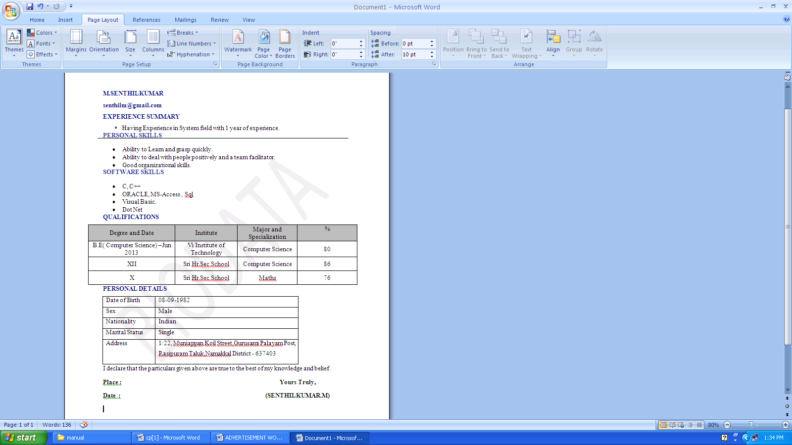

OUTPUT:-

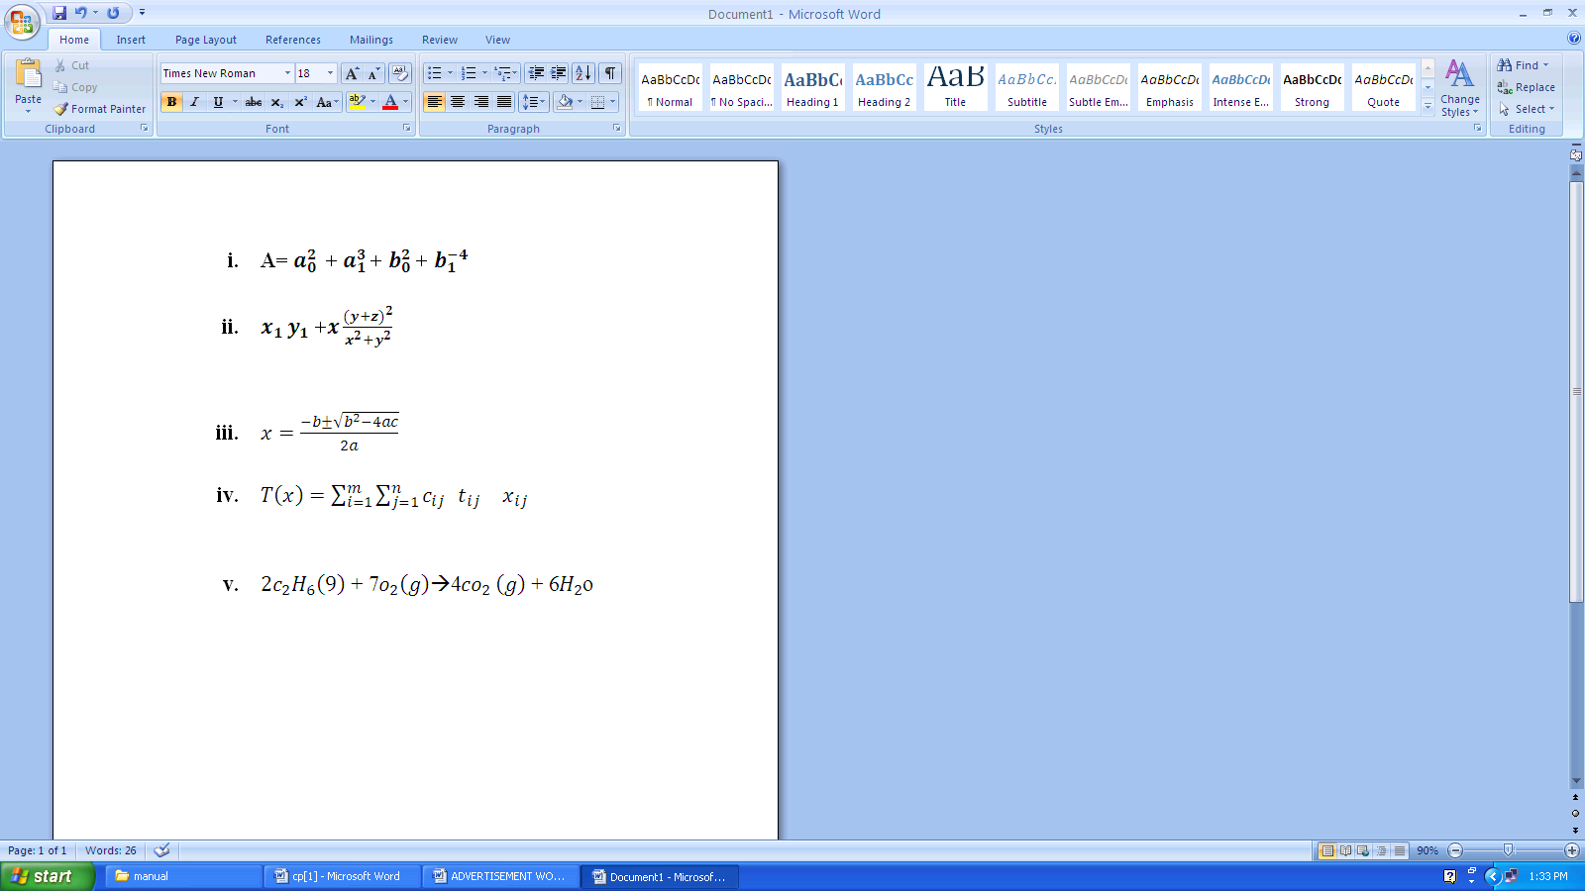

OUTPUT:-

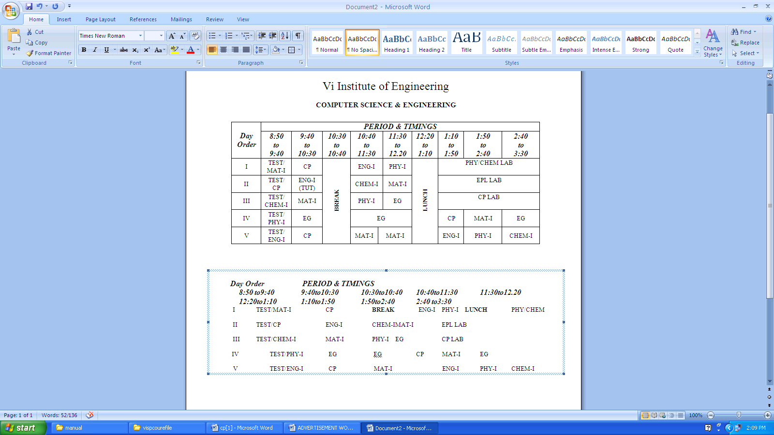

OUTPUT:-
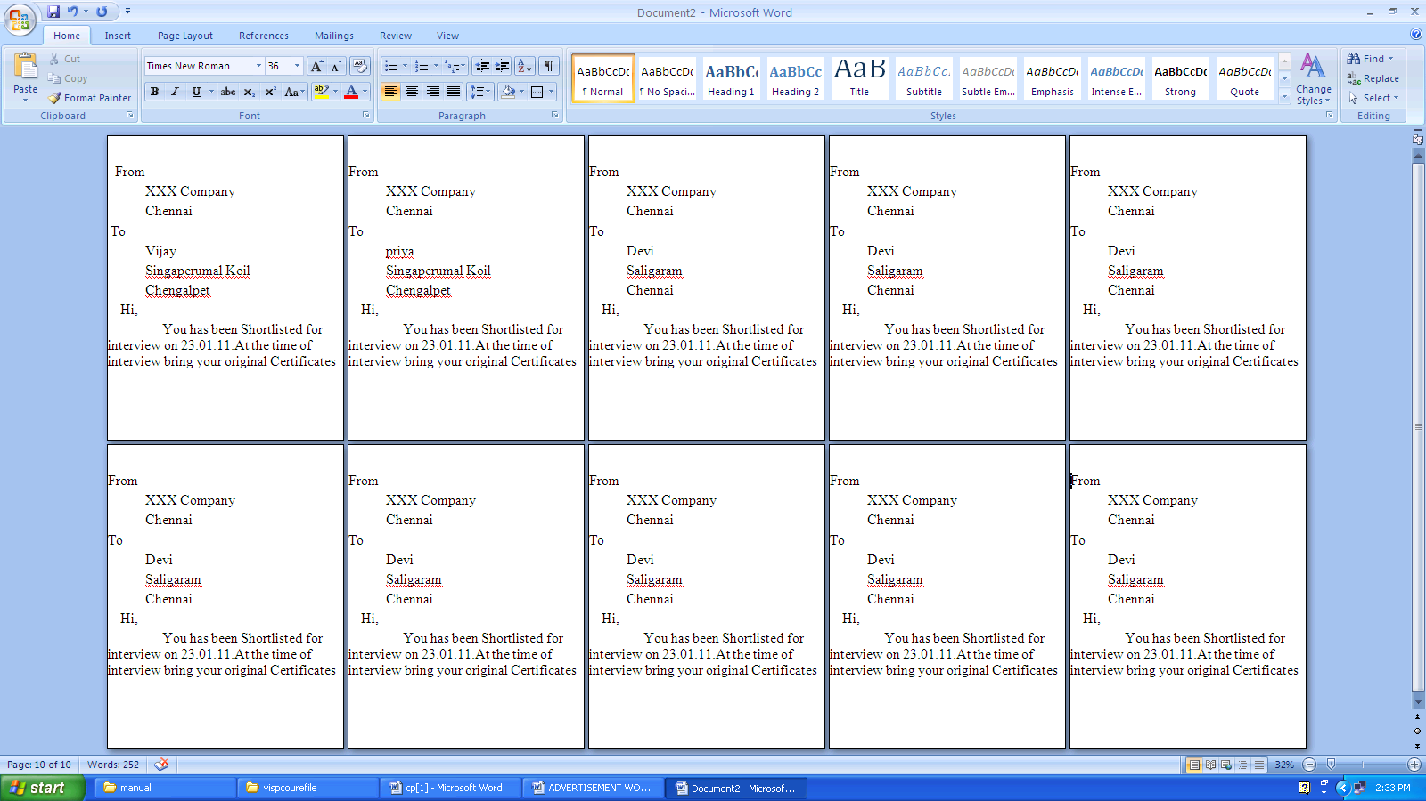

OUTPUT:-

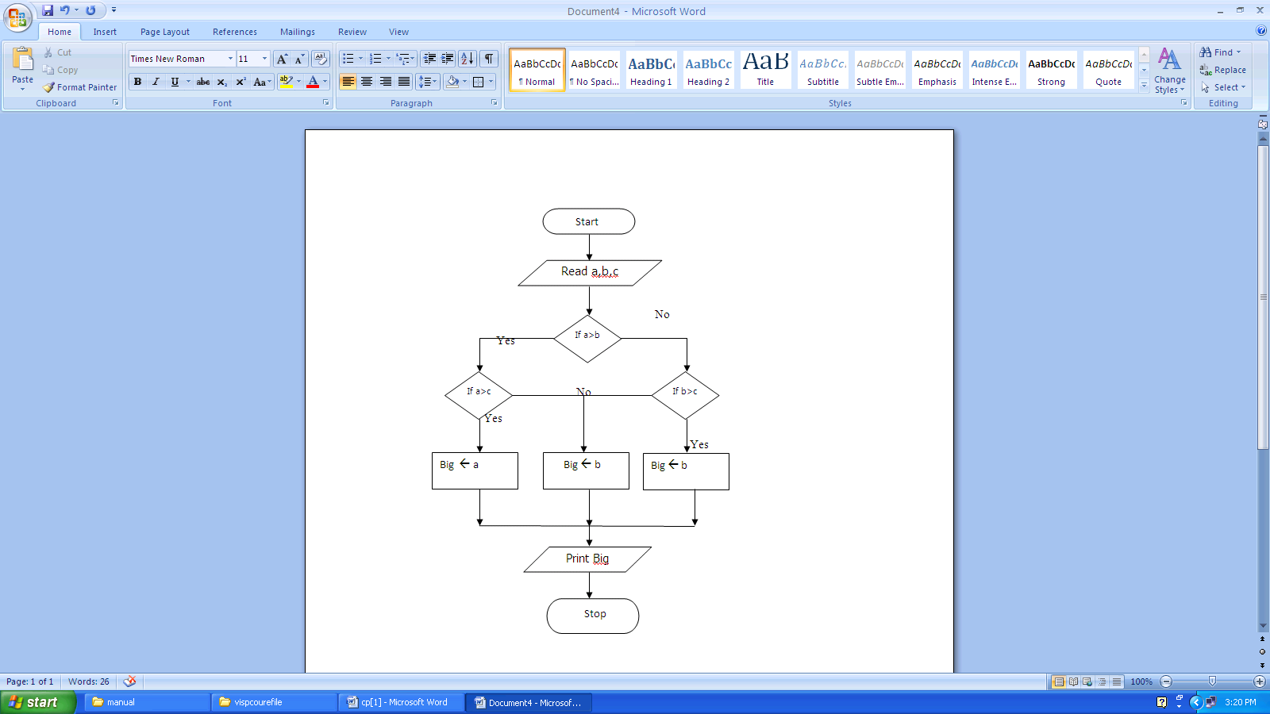

OUTPUT:-
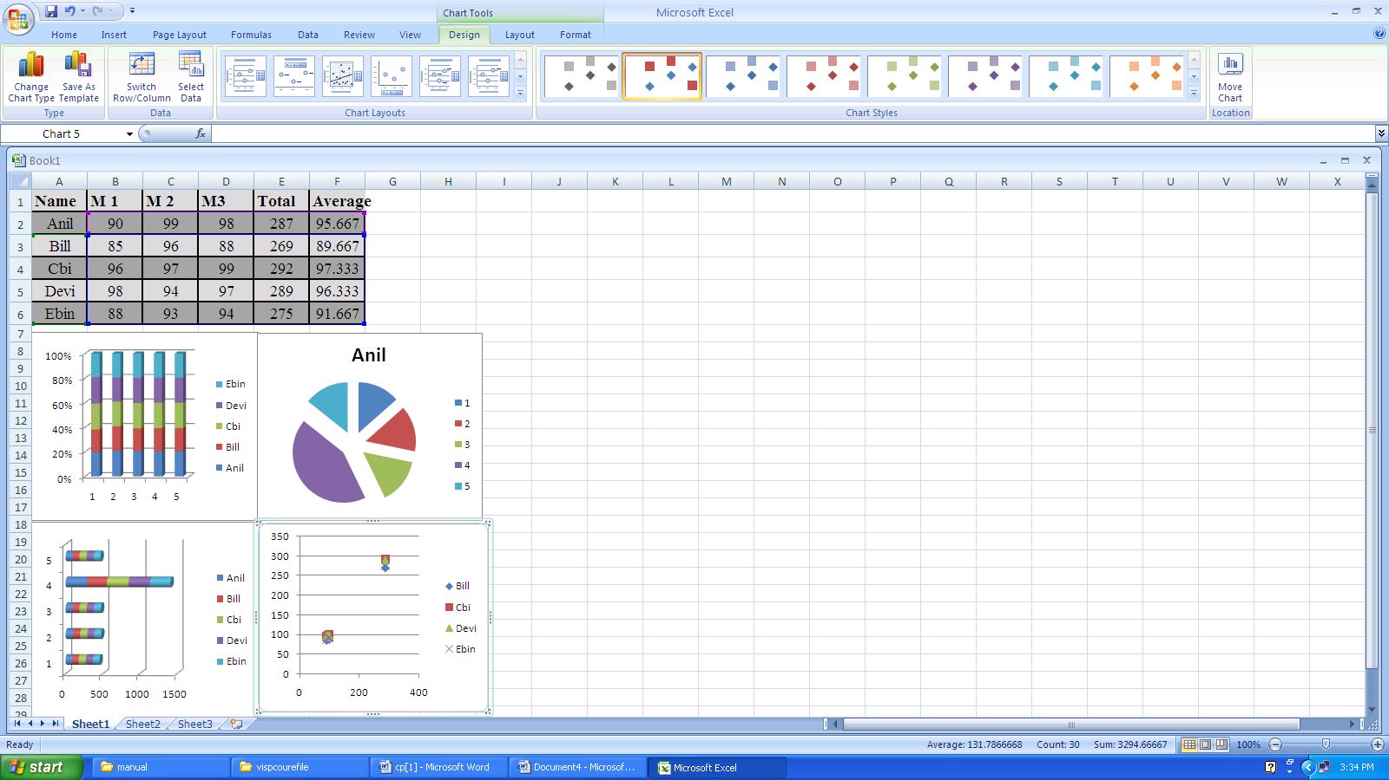

OUTPUT:-
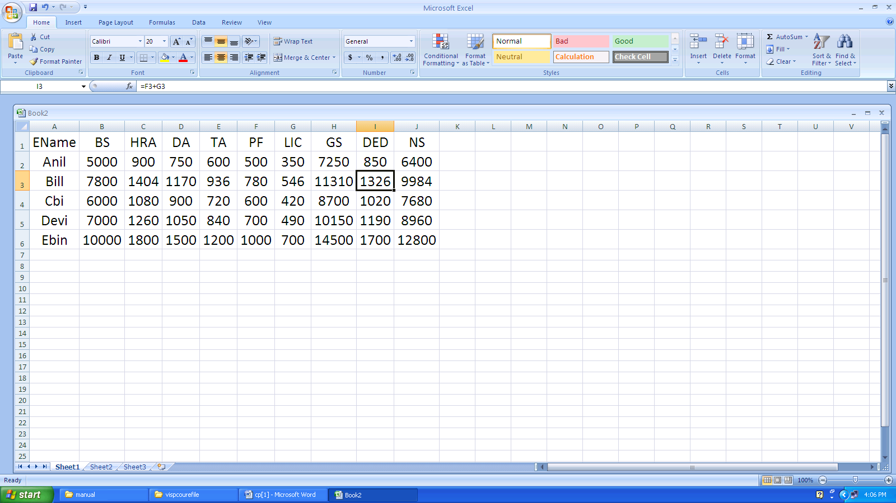

OUTPUT:-

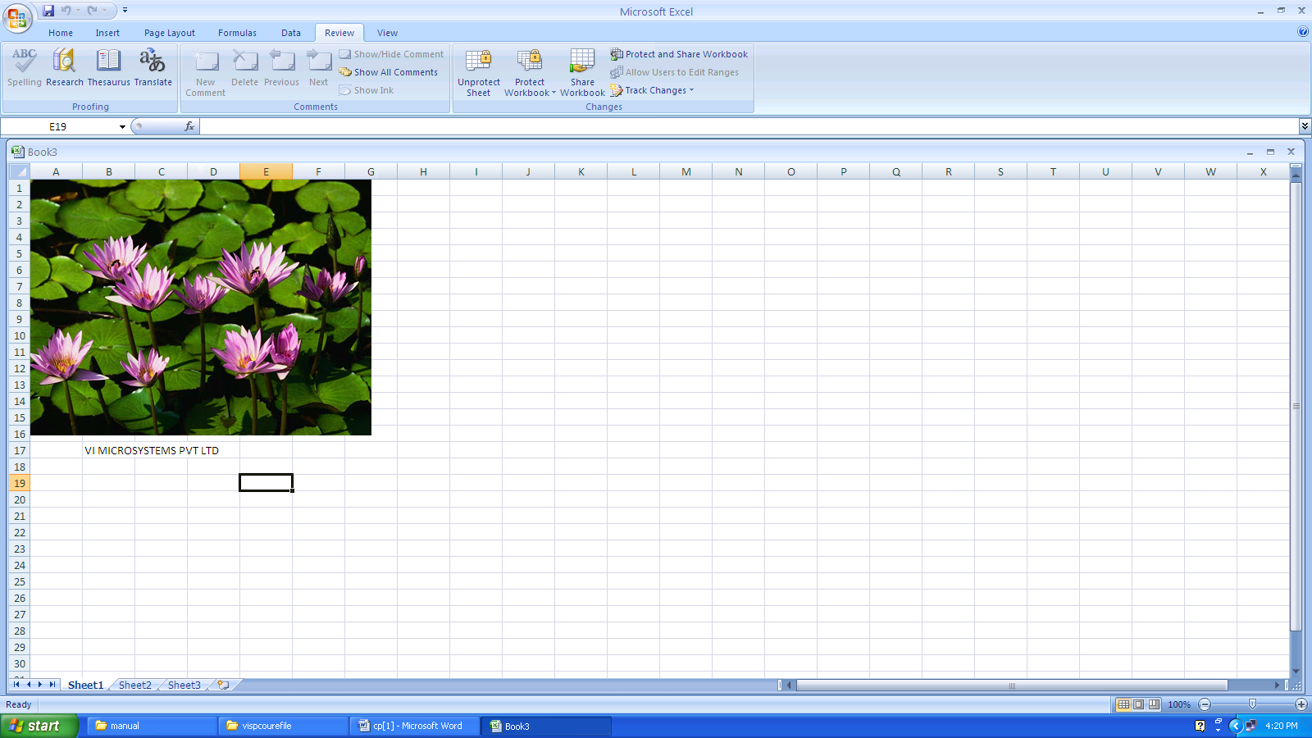

OUTPUT:-
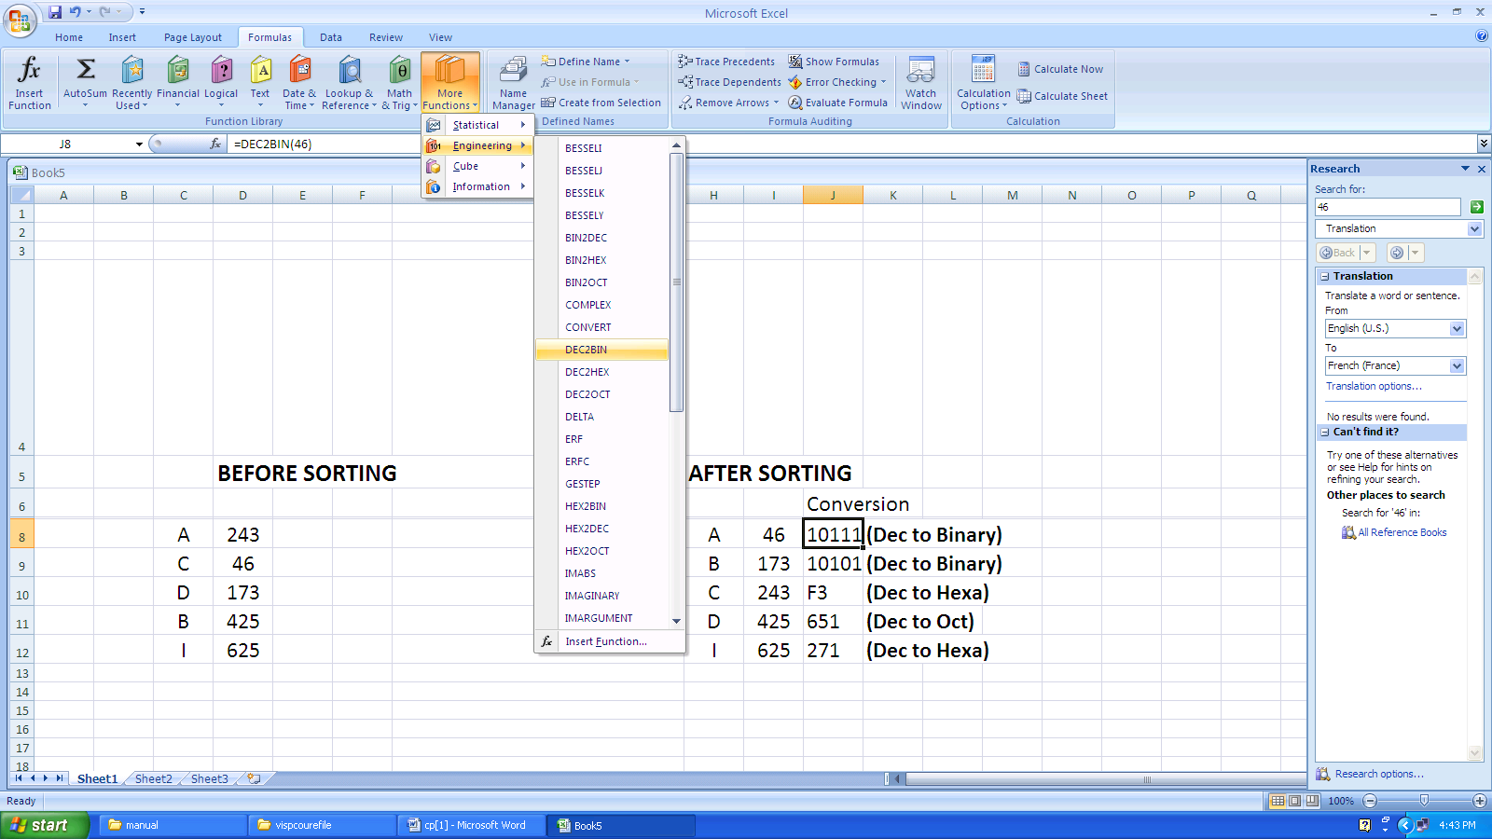
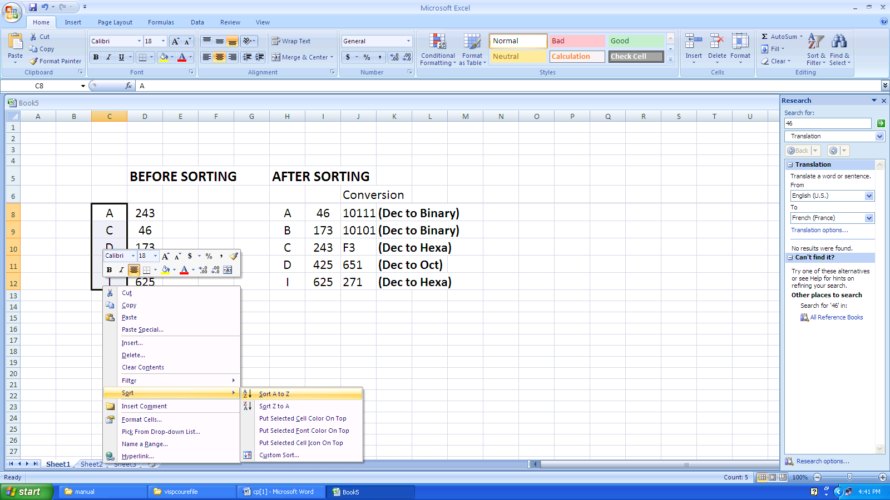

PROGRAM:
#include<stdio.h>
#include<conio.h>
main()
{
float b;
int a;
printf("\nEnter an Integer\n");
scanf("%d",&a);
b=(float)a;
printf("\nThe Converted float value is %f",b);
}

OUTPUT:
Enter an Integer
45
The Converted float value is 45.00000

PROGRAM:
#include<stdio.h>
#include<conio.h>
main()
{
int a,b,c;
printf("Enter Number 1\n");
scanf("%d",&a);
printf("Enter Number 2\n");
scanf("%d",&b);
c=a*b;
printf("\nThe Multiplication Result is %d\n",c);
}

OUTPUT:
Enter Number 1
34
Enter Number 2
7
The Multiplication Result is 238

PROGRAM:
#include<stdio.h>
#include<conio.h>
main()
{
int m1,m2,m3,m4,m5,tot;
float avg;
printf("Enter 5 Marks\n");
scanf("%d%d%d%d%d",&m1,&m2,&m3,&m4,&m5);
tot=m1+m2+m3+m4+m5;
avg=tot/5;
printf("\nThe Average is %f\n",avg);
}

OUTPUT:
Enter 5 Marks
80
75
85
90
95
The Average is 92.5

PROGRAM:
#include<stdio.h>
#include<conio.h>
main()
{
int v,g,c,d,dr;
float r,nr;
printf("Enter the value of v\n");
scanf("%d",&v);
printf("Enter the value of g\n");
scanf("%d",&g);
printf("Enter the value of c\n");
scanf("%d",&c);
printf("Enter the value of d\n");
scanf("%d",&d);
nr=(2*v)+(6.22*c*d);
dr=g+v;
r=nr/dr;
printf("The Evaluated Result is %f\n",r);
}

OUTPUT:
Enter the value of v
2
Enter the value of g
4
Enter the value of c
6
Enter the value of d
8
The Evaluated Result is 50.426666

PROGRAM:
#include<stdio.h>
#include<conio.h>
main()
{
int mm,m;
printf("Enter the Millimeter\n");
scanf("%d",&mm);
m=mm*1000;
printf("The Converted meter is %d",m);
}

OUTPUT:
Enter the Millimeter
12
The Converted meter is 12000

PROGRAM:

#include<stdio.h>
#include<conio.h>
main()
{
int a,rem;
printf("Enter a Number\n");
scanf("%d",&a);
rem=a%2;
if(rem==0)
printf("The Given Number is Even");
else
printf("The Given Number is Odd");
}

OUTPUT:
Enter a Number
13
The Given Number is Odd

PROGRAM:
#include<stdio.h>
#include<conio.h>
main()
{
int a,b,c;
printf("Enter 3 Numbers\n");
scanf("%d%d%d",&a,&b,&c);
if(a>b)
{
if(a>c)
{
printf("The First Number %d(a) is Biggest\n",a);
}
}
else if(b>c)
16
{
printf("The Second Number %d(b) is Biggest\n",b);
}
else
printf("The Third Number %d(c) is Biggest\n",c);
}

OUTPUT:
Enter 3 Numbers
5
9
2
The Second Number 89(b) is Biggest

PROGRAM:
#include<stdio.h>
main()
{
int i,n,sum=0;
printf("Enter the range\n");
scanf("%d",&n);
i=1;
while(i<=n)
{
sum=sum+i;
i++;
}
printf("\nThe sum of first %d numbers is %d\n",n,sum);
}

OUTPUT:
Enter the range
16
The sum of first 16 numbers is 136

PROGRAM:
#include<stdio.h>
main()
{
int n,i,sum=0;
printf("Enter a Number\n");
scanf("%d",&n);
do
{
i=n%10;
sum=sum+i;
n=n/10;
}while(n>0);
printf("The Sum of digit is %d\n",sum);
}

OUTPUT:
Enter a Number
5891
The Sum of digit is 23

PROGRAM:
#include<stdio.h>
#include<conio.h>
#include<math.h>
int factorial(int n)
{
int i,sum=1;
for(i=1;i<=n;i++)
sum=sum*i;
return sum;
}
main()
{
int i,n,j,dr;
float res=0.0,x,nr;
printf("\nEnter the Value of x\n");
scanf("%f",&x);
printf("\nEnter the total no of terms\n");
scanf("%d",&n);
j=1;
for(i=1;i<n*2;i+=2)
{
nr=pow(x,i)*j;
dr=factorial(i);
res+=(nr/dr);
j=-j;
}
printf("The Result of sine series is : %f\n",res);
}
OUTPUT:
Enter the Value of x
0.21
Enter the total no of terms
5
The Result of sine series is : 0.208460

PROGRAM:
#include<stdio.h>
#include<conio.h>
main()
{
int a,b,ch,c;
printf("\nEnter the Number 1:\n");
scanf("%d",&a);
printf("\nEnter the Number 2:\n");
scanf("%d",&b);
printf("\n1.Add\n2.Subtract\n3.Multiply\n4.Divide\n");
printf("\nEnter the Choice:\n");
scanf("%d",&ch);
switch(ch)
{
case 1:
c=a+b;
printf("\n %d + %d = %d\n",a,b,c);
break;
case 2:
c=a-b;
printf("\n %d - %d = %d\n",a,b,c);
break;
case 3:
c=a*b;
printf("\n %d * %d = %d\n",a,b,c);
break;
case 4:
c=a/b;
printf("\n %d / %d = %d\n",a,b,c);
break;
}
}

OUTPUT:
Enter the Number 1:
15
Enter the Number 2:
56
1.Add
2.Subtract
3.Multiply
4.Divide

Enter the Choice:
2
15 - 56 = -41
Enter the Choice:
3
15*56=840

PROGRAM:
#include<stdio.h>
#include<conio.h>
#include<math.h>
main()
{
int a,i,sum=0,n,ch,m;
printf("\nEnter a Number\n");
scanf("%d",&a);
printf("\n1.Palindrome\n2.Armstrong\n3.Prime\n");
printf("\nEnter the Choice:\n");
scanf("%d",&ch);
switch(ch)
{
case 1:
n=a;
while(a>0)
{
i=a%10;
sum=(sum*10)+i;
a=a/10;
}
if(n==sum)
printf("Given Number is Palindrome\n");
else
printf("Given Number is Not Palindrome\n");
break;
case 2:
n=a;
do
{
i=a%10;
sum=sum+(i*i*i);
a=a/10;
}while(a>0);
if(n==sum)
printf("Given Number is Armstrong\n");
else

printf("Given Number is Not Armstrong\n");
break;
case 3:
m=5;
n=sqrt(a);
for(i=2;i<=n;i++)
{
if(a%i==0)
{
m=0;
break;
}
}
if(m==0)
printf("Given Number is Prime\n");
else
printf("Given Number is Not Prime\n");
break;
}
}

OUTPUT:
Enter a Number
121
1.Palindrome
2.Armstrong
3.Prime
Enter the Choice:
1
Given Number is Palindrome

PROGRAM:
#include<stdio.h>
#include<conio.h>
main()
{
int i,n,a[10],sum=0;
printf("Enter total no. of Elements\n");
scanf("%d",&n);
printf("Enter Array elements one by one\n");
for(i=0;i<n;i++)
scanf("%d",&a[i]);
for(i=0;i<n;i++)
sum=sum+a[i];
printf("The Sum of Array Elements is %d\n",sum);
}

OUTPUT:
Enter total no. of Elements
8
Enter Array elements one by one
15
69
32
10
45
66
32
11
The Sum of Array Elements is 280

PROGRAM:
#include<stdio.h>
#include<conio.h>
main()
{
int i,n,a[10];
printf("Enter total no. of Elements\n");
scanf("%d",&n);
printf("Enter Array elements one by one\n");
for(i=0;i<n;i++)
scanf("%d",&a[i]);
printf("The even numbers of given array:\n");
for(i=0;i<n;i++)
{
if(a[i]%2==0)
printf("%d\n",a[i]);
}
}

OUTPUT:
Enter total no. of Elements
6
Enter Array elements one by one
98
11
35
61
22
14
The even numbers of given array:
98
22
14

PROGRAM:
#include<stdio.h>
#include<conio.h>
#include<string.h>
main()
{
int mat1[10][10],mat2[10][10],resultant[10][10]={0};
int m1,n1,m2,n2,I,j,k;
printf(“enter the order of matrix 1:”);
scanf(“%d %d”,&m1,&n1);
printf(“enter the elements of matrix:”);
for(i=0;i<m1;i++)
{
for(j=0;j<n1;j++)
scanf(“%d”,&mat1[i][j]);
}
printf(“enter the order of matrix 2:”);
scanf(“%d %d”,&m2,&n2);
printf(“enter the elements of matrix:”);
for(i=0;i<m2;i++)
{
for(j=0;j<n2;j++)
scanf(“%d”,&mat2[i][j]);
}
if(n1!=m2)
{
printf(“matrices are not compatible for multiplication”);
exit(0) ;
}
else
{
for(i=0;i<m1;i++)
for(j=0;j<n2;j++)
for(k=0;k<n1;k++)
resultant[i][j]=resultant[i][j]+mat1[i][k]*mat2[k][j];
}
printf(“the result of matrix multiplication is”);
for(i=0;i<m1;i++)

{
for(j=0;j<n2;j++)
printf(“%d”, resultant is[i][j]);
printf(“\n”);
}
}

OUTPUT:
enter the order of matrix 1: 2 3
enter the elements of matrix:
1 2 3
4 5 6
enter the order of matrix 2: 3 3
enter the elements of matrix:
2 3 4
1 2 3
1 1 0
The result of matrix multiplication is
7 10 10
19 28 31

PROGRAM:
#include<stdio.h>
#include<conio.h>
#include<string.h>
main()
{
char s[20],s1[20];
printf("Enter a String\n");
scanf("%s",s);
strcpy(s1,s);
if(strcmp(s,s1)==0)
printf("The Given String is Palindrome\n");
else
printf("The Given String is Not Palindrome\n");
}

OUTPUT:
Enter a String
madam
The Given String is Palindrome

PROGRAM:
#include<stdio.h>
#include<conio.h>
#include<string.h>
main()
{
char s[20],s1[20];
printf("Enter a String1\n");
scanf("%s",s);
printf("Enter a String2\n");
scanf("%s",s1);
strcat(s,s1);
printf("The Concatenated String is %s\n",s);
}

OUTPUT:
Enter a String1
hai
Enter a String2
hello
The Concatenated String is haihello

PROGRAM:
#include<stdio.h>
#include<conio.h>
void isleap()
{
int yr;
printf("Enter a Year\n");
scanf("%d",&yr);
if(yr%4==0)
printf("Given Year is Leap year");
else
printf("Given Year is Not a Leap year");
}
main()
{
isleap();
}

OUTPUT:
Enter a Year
1965
Given Year is Not a Leap year

PROGRAM:
#include<stdio.h>
#include<conio.h>
#include<math.h>
float area()
{
int a,b,c;
float s,ar;
printf("Enter 3 Sides\n");
scanf("%d%d%d",&a,&b,&c);
s=(a+b+c)/2;
ar=sqrt(s*(s-a)*(s-b)*(s-c));
return ar;
}
main()
{
float a;
a=area();
printf("The Area of Triangle is %f\n",a);
}

OUTPUT:
Enter 3 Sides
12
8
7
The Area of Triangle is 19.748418

PROGRAM:
#include<stdio.h>
#include<conio.h>
void sorting(int a[],int n)
{
int i,j,t;
for(i=0;i<n-1;i++)
{
for(j=i+1;j<n;j++)
{
if(a[i]>a[j])
{
t=a[i];
a[i]=a[j];
a[j]=t;
}
}
}
printf("Array Elemets before sorting\n");
for(i=0;i<n;i++)
printf("%d\t",a[i]);
}
main()
{
int i,a[10],n;
printf("Enter total no. of elements\n");
scanf("%d",&n);
printf("Enter Array Elements one by one\n");
for(i=0;i<n;i++)
scanf("%d",&a[i]);
printf("Array Elemets before sorting\n");
for(i=0;i<n;i++)
printf("%d\t",a[i]);
printf("\n");
sorting(a,n);
}

OUTPUT:
Enter total no. of elements
6
Enter Array Elements one by one
21
2
9
45
30
11
Array Elements before sorting
21 2 9 45 30 11
Array Elements before sorting
2 9 11 21 30 45

PROGRAM:
#include<stdio.h>
#include<conio.h>
int small(int a[],int n)
{
int s,i;
s=a[0];
for(i=0;i<n;i++)
{
if(a[i]<s)
s=a[i];
}
return s;
}
main()
{
int i,a[10],n,s;
printf("Enter total no. of elements\n");
scanf("%d",&n);
printf("Enter Array Elements one by one\n");
for(i=0;i<n;i++)
scanf("%d",&a[i]);
printf("Array Elemets:\n");
for(i=0;i<n;i++)
printf("%d\t",a[i]);
printf("\n");
s=small(a,n);
printf("The Smallest element of given array is %d",s);
}

OUTPUT:
Enter total no. of elements
5
Enter Array Elements one by one
1
98
2
66
0
Array Elements:
1 98 2 66 0
The Smallest element of given array is 0

PROGRAM:
#include<stdio.h>
#include<conio.h>
void swap(int,int);
void main()
{
int a=10,b=20;
printf(“Before swap values are: %d%d\n”,a,b);
swap(a,b);
printf(“After swap values are: %d%d\n”,a,b);
}
void swap(int x,int y)
{
x=x+y;
y=x-y;
x=x-y;
printf(“In swap functions values are: %d%d\n”,x,y);
}

OUTPUT:
Before swap values are: 10 20
In swap functions values are: 20 10
After swap values are:10 20

PROGRAM:
#include<stdio.h>
#include<conio.h>
void swap(int*,int*);
void main()
{
int a=10,b=20;
printf(“Before swap values are: %d%d\n”,a,b);
swap(&a,&b);
printf(“After swap values are: %d%d\n”,a,b);
}
void swap(int* x,int *y)
{
*x=*x+*y;
*y=*x-*y;
*x=*x-*y;
printf(“In swap functions values are: %d%d\n”,*x,*y);
}

OUTPUT:
Before swap values are: 10 20
In swap functions values are: 20 10
After swap values are:20 10

PROGRAM:
#include<stdio.h>
#include<conio.h>
int factorial(int n)
{
if(n==0 || n==1)
return 1;
else
return n*factorial(n-1);
}
main()
{
int n;
printf("\nEnter a Number\n");
scanf("%d",&n);
printf("\nThe factorial of %d is %d\n",n,factorial(n));
}

OUTPUT:
Enter a Number 6
The factorial of 6 is 720

PROGRAM:
#include<stdio.h>
int sum(int n,int s)
{
if(n<10)
return n;
else
return (n%10)+sum(n/10,s);
}
main()
{
int n,s=0;
printf("\nEnter a Number\n");
scanf("%d",&n);
s=sum(n,s);
printf("\nThe sum of digits %d is %d\n",n,sum(n,s));
}

OUTPUT:
Enter a Number 46612
The sum of digits 46612 is 19

PROGRAM:
#include<stdio.h>
#include<conio.h>
struct student
{
int rno,m1,m2,m3;
float avg;
char name[20],dept[10];
};
main()
{
struct student s;
printf("Enter the Student Details:\n");
printf("Enter the Stuent roll no:\n");
scanf("%d",&s.rno);
printf("Enter the Stuent Name:\n");
scanf("%s",&s.name);
printf("Enter the Stuent Dept:\n");
scanf("%s",&s.dept);
printf("Enter the 3 marks:\n");
scanf("%d%d%d",&s.m1,&s.m2,&s.m3);
s.avg=(s.m1+s.m2+s.m3)/3;
printf("The Student Average is :%f\n",s.avg);
}
OUTPUT:
Enter the Student Details:
Enter the Stuent roll no:
12
Enter the Stuent Name:
Kumar
Enter the Stuent Dept:
CSE
Enter the Stuent marks:
40
18
90
The Student Average is :49.000000

PROGRAM:
#include<stdio.h>
#include<conio.h>
struct student
{
int rno,m1,m2,m3;
float avg;
char name[20],dept[10];
};
void find_student(int a,struct student s[],int n)
{
int i;
printf("The Student Detail of %d\n",a);
for(i=0;i<n;i++)
{
if(s[i].rno==a)
{
printf("%s\t%s\t%d\t%d\t%d\t%f\n",s[i].name,s[i].dept,s[i].m1,s[i].m
2,s[i].m3,s[i].avg);
break;
}
}
}
main()
{
int i,n,rno;
struct student s[10];
printf("Enter total no. of Students\n");
scanf("%d",&n);
for(i=0;i<n;i++)
{
printf("Enter the Student %d Details:\n",(i+1));
printf("Enter the roll no:\n");
scanf("%d",&s[i].rno);
printf("Enter the Name:\n");
scanf("%s",&s[i].name);
printf("Enter the Dept:\n");
scanf("%s",&s[i].dept);

printf("Enter the 3 marks:\n");
scanf("%d%d%d",&s[i].m1,&s[i].m2,&s[i].m3);
s[i].avg=(s[i].m1+s[i].m2+s[i].m3)/3;
}
printf("Enter the rollno to find:\n");
scanf("%d",&rno);
find_student(rno,s,n);
}

OUTPUT:
Enter total no. of Students
2
Enter the Student 1 Details:
Enter the roll no:
12
Enter the Name:
Kumar
Enter the Dept:
cse
Enter the 3 marks:
45
67
88
Enter the Student 2 Details:
Enter the roll no:
13
Enter the Name:
Prabhu
Enter the Dept:
cse
Enter the 3 marks:
77
89
67
Enter the rollno to find:
13
The Student Detail of 13
Prabhu cse 77 89 67 77.000000

PROGRAM:
#include<stdio.h>
#include<conio.h>
union book
{
int price;
char bname[20];
};
main()
{
union book b;
printf("Enter the Book Details:\n");
printf("Enter the Book Name:\n");
scanf("%s",&b.bname);
printf("Enter the Book Price:\n");
scanf("%d",&b.price);
printf("BOOK DETAILS:\n");
printf("%s\t%d\n",b.bname,b.price);
printf("Enter the Book Name:\n");
scanf("%s",b.bname);
printf("Book Name=%s\n",b.bname);
}

OUTPUT:
Enter the Book Details:
Enter the Book Name:
English
Enter the Book Price:
150
BOOK DETAILS:
150
Enter the Book Name:
English
Book Name=English

PROGRAMS
#include<stdio.h>
int main ()
{
int n = 20, *pntr;
pntr = &n;
printf("Address of n variable: %x\n", &n );
printf("Address stored in pntr variable: %x\n", pntr );
printf("Value of *pntr variable: %d\n", *pntr );
return 0;
}

OUTPUT:
Address of n variable:2cb60f04
Address stored in pntr variable: 2cb60f04
Value of *pntr variable:20

PROGRAM

#include<stdio.h>
#include<string.h>
#include<stdlib.h>
int main()
{
char *mem_alloc;
mem_alloc = malloc( 15 * sizeof(char) );
if(mem_alloc== NULL )
{
printf("Couldn't able to allocate requested memory\n");
}
else
{
strcpy( mem_alloc,"w3schools.in");
}
printf("Dynamically allocated memory content : %s\n", mem_alloc );
free(mem_alloc);
}

OUTPUT:
Dynamically allocated memory content : W3Schools.in

PROGRAM:
#include<stdio.h>
#include<stdlib.h>
int main()
{
char ch, source_file[25], target_file[25];
FILE *source, *target;
printf("Enter name of file to copy\n");
gets(source_file);
source = fopen(source_file, "r");
if( source == NULL )
{
printf("Press any key to exit...\n");
exit(EXIT_FAILURE);
}
printf("Enter name of target file\n");
gets(target_file);
target = fopen(target_file, "w");
if( target == NULL )
{
fclose(source);
printf("Press any key to exit...\n");
exit(EXIT_FAILURE);
}
while( ( ch = fgetc(source) ) != EOF )
fputc(ch, target);
printf("File copied successfully.\n");
fclose(source);
fclose(target);
return 0;
}

OUTPUT:
Enter name of file to copy:
File1.c
Enter name of target file:
file2.c
File copied successfully

PROGRAM
#include <stdio.h>
int main()
{
FILE *fp;
int no_lines = 0;
char filename[40], sample_chr;
printf("Enter file name: ");
scanf("%s", filename);
fp = fopen(filename, "r");
sample_chr = getc(fp);
while (sample_chr != EOF)
{
if (sample_chr == '')
{
no_lines=no_lines+1;
}
sample_chr = getc(fp);
}
fclose(fp);
printf("There are %d lines in %s", no_lines, filename);
return 0;
}
OUTPUT:
Enter the file name:file1.txt
There are 5 lines in file1.txt

